

Web Development

QAC020C153S



April 7, 2019

|  |  |  |  |  |  |  |  |
| --- | --- | --- | --- | --- | --- | --- | --- |
| Submission Coversheet | | | |  |  |  |  |
|  |  |  |  |  |  |  |  |
| **Student ID Number**  *(Do not include student name as anonymous marking is implemented)* | Mateusz Utracki-Janeta | | | | | | |
| **Programme Title** | Bsc Computing Technologies | | | | | | |
| **Module Title** | Website Development | | | | | | |
| **Module Code** *(listed on Moodle and in LTAFP)* |  | | | | | | |
| **Module Convenor** |  | | | | | | |
| **Coursework Title** | Unque Wears | | | | | | |
| **Academic Declaration:**  *Students are reminded that the electronic copy of their essay may be checked, at any point during their degree, with Turnitin or other plagiarism detection software for plagiarised material.* | | | | | | | |
| **Word Count** | 539 | | | **Date Submitted** | | **08/04/2019** | |
|  |  | | |  | |  | |

Table of Contents

1 Introduction 3

2 *Design* documentation 3

2.1 Organisation 3

2.2 Home page 6

2.3 Sizes page 7

2.4 Products page 8

2.4.1 Product gallery page 10

2.5 Contact page 12

2.6 Wholesale page 13

2.7 Colour schemes 13

3 Development: 14

3.1 Source codes and styles 14

3.2 Breakpoints 21

4 *Testing* and validation: 25

4.1 XAMMP server installation process 32

4.2 Page running on server 35

4.3 Submission buttons test 42

4.4 Cross browser running test 46

5 References 47

6 Appendices 47

# Introduction

This is a report about design, development and deployment of a website for Unque Wears a shoe shop located in London.

Website is created using HTML (Hyper-Text Markup Language), styled using CSS(Cascade StyleSheets) and functionalities are added with JavaScript. It is deployed using XAMMP server which installation process is documented in this report.

Website contains of 5 menu pages to navigate the website, 1 sub-menu page, 4 gallery pages to display products, 48 product pages, 2 empty pages for Terms and Conditions and Privacy Policy.

# *Design* documentation

Unique Shoes is a website project which purpose is to sell shoes online and give availability for big quantity buyers to order online.

## Organisation

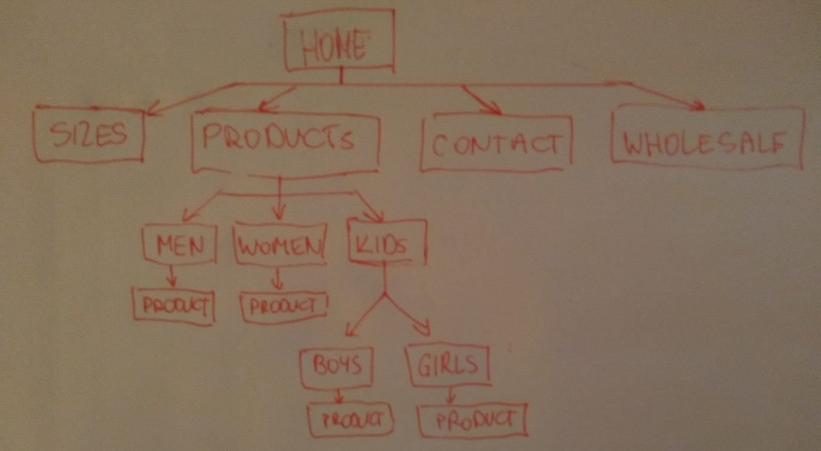

Figure 1

Figure 1 shows a sketch of website organisation. It is hierarchical organisation which is often used for commercial purposes. We have a clearly defined home page and I preserved the three click rule which allows user to get to any page of the web in just three clicks. The exception is kids product page, you need 4 clicks for that.

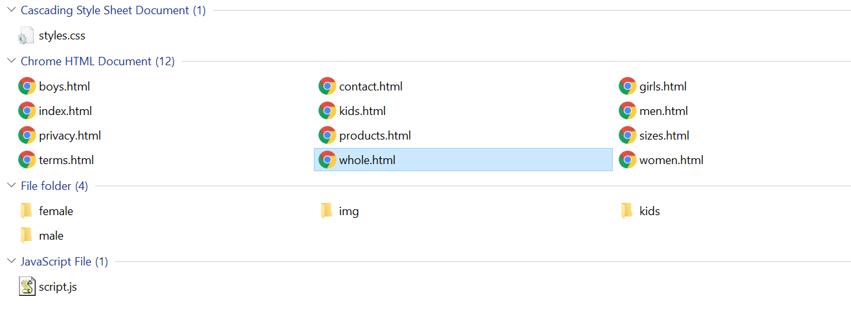

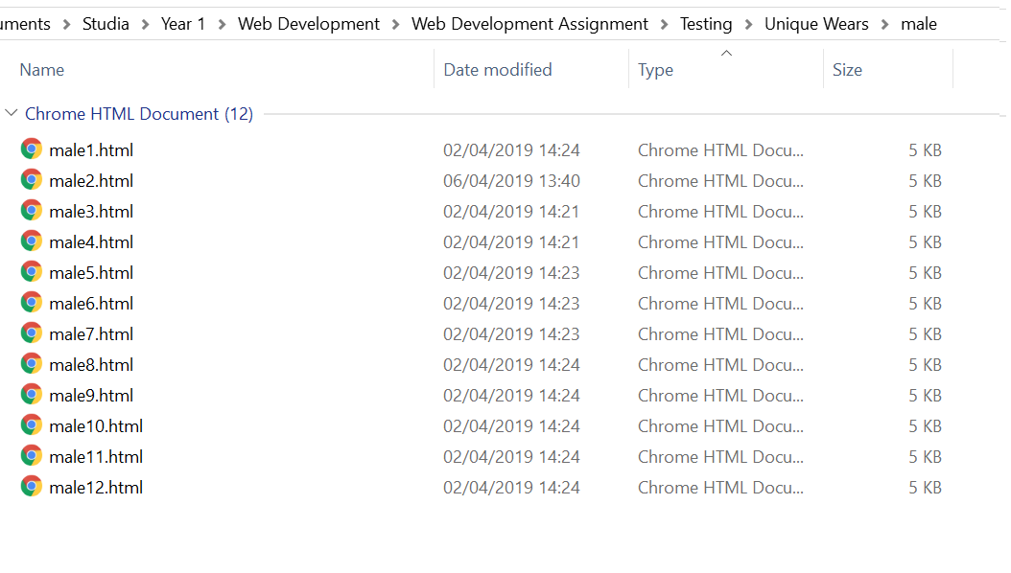

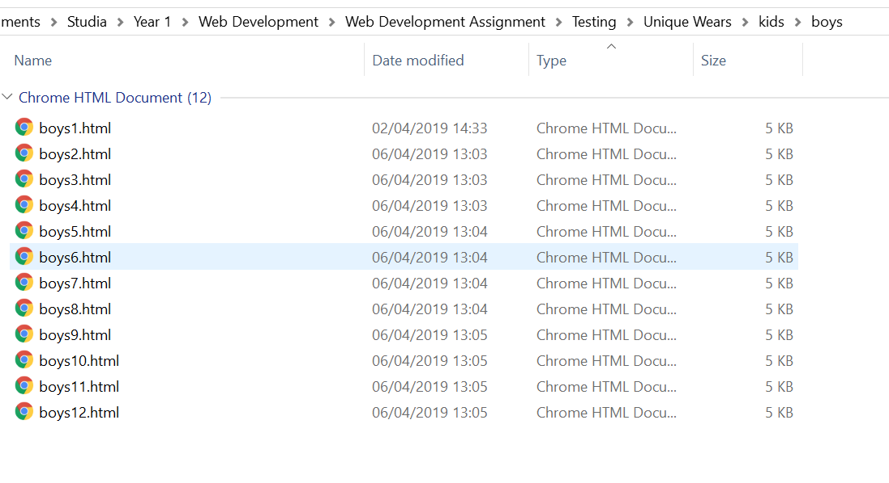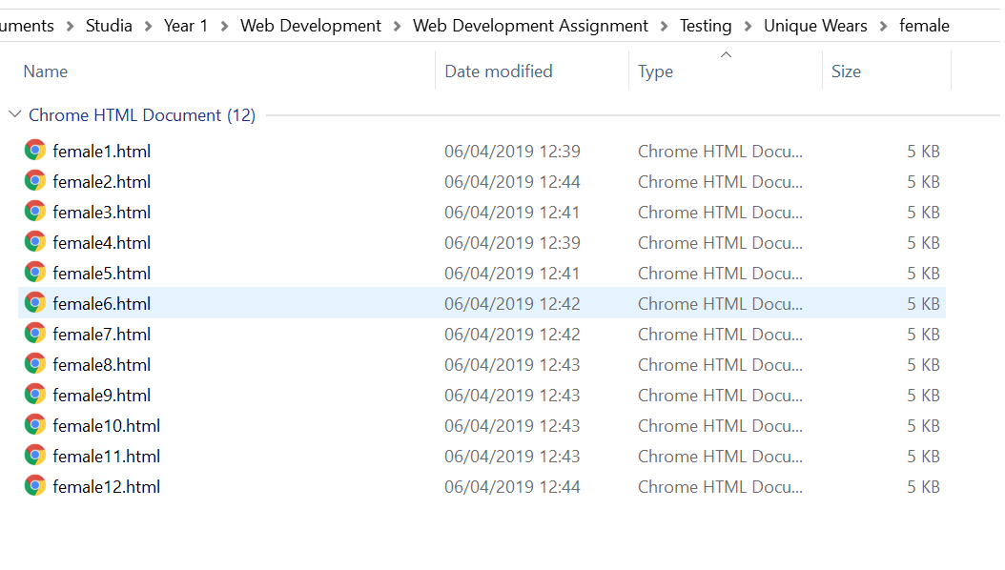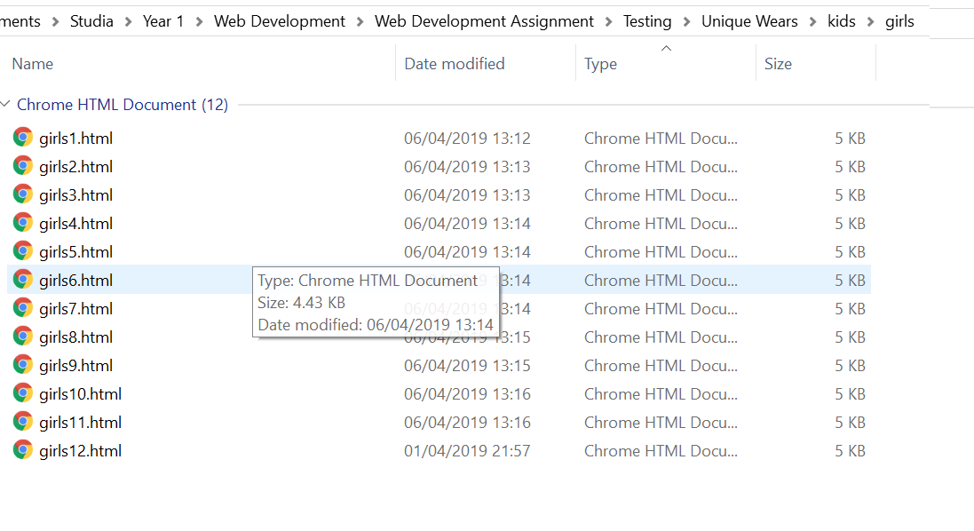

## Home page

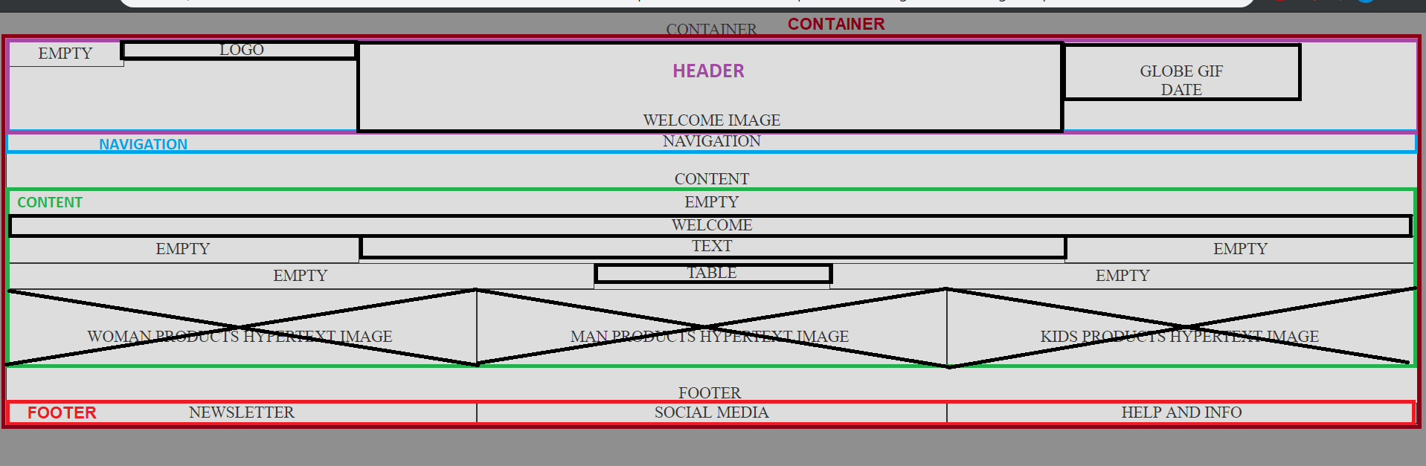

Figure 2

Figure 2 shows wireframe for the home page. Navigation div contains anchor elements which are linked to pages sizes, products, contact, whole, on every page in footer section there are anchor elements linking to Privacy Policy, Terms and Conditions and contact page. Different colours show different division which are named according to their content. Sections header, navigation and footer are the same for every page. The content page is the page which is dynamic and changes. Content of home page shows a welcome text in <h1> heading tag followed by a paragraph in <p> and a <table> with business opening hours. Below that are three divisions which hold anchor element <a> containing <img> element which links to product corresponding with the image.

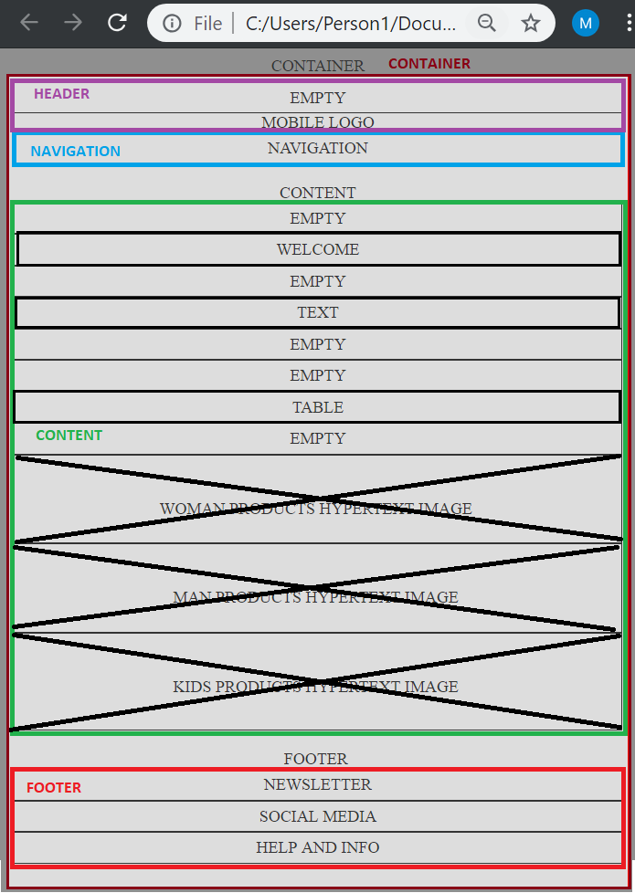

Figure 3 Home page mobile wireframe

## Sizes page

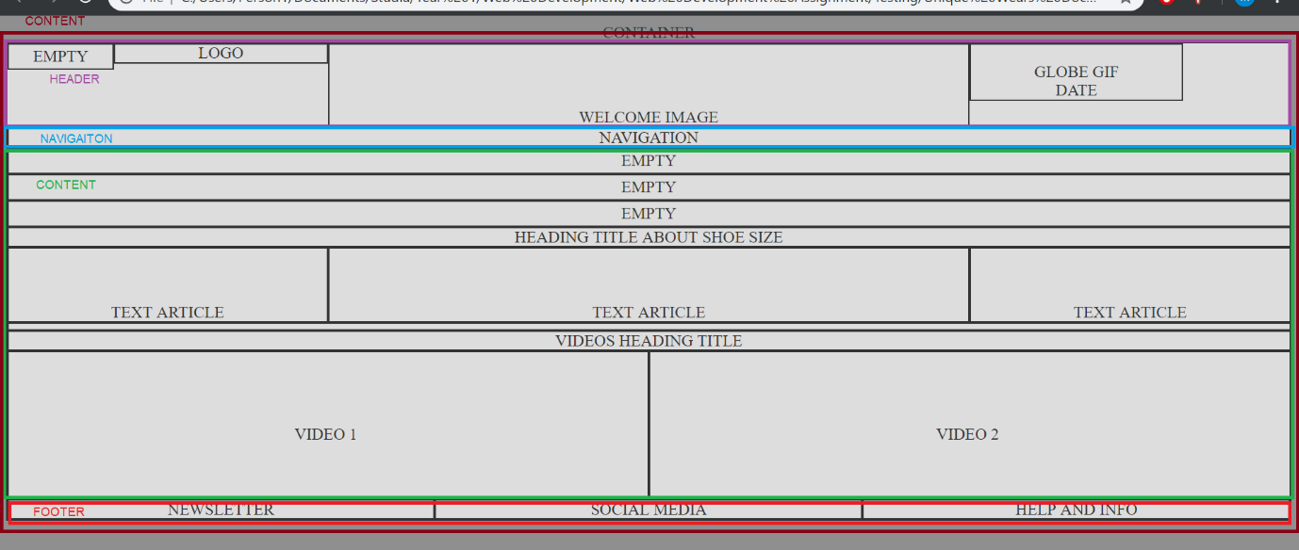

Figure 4 Sizes page wireframe

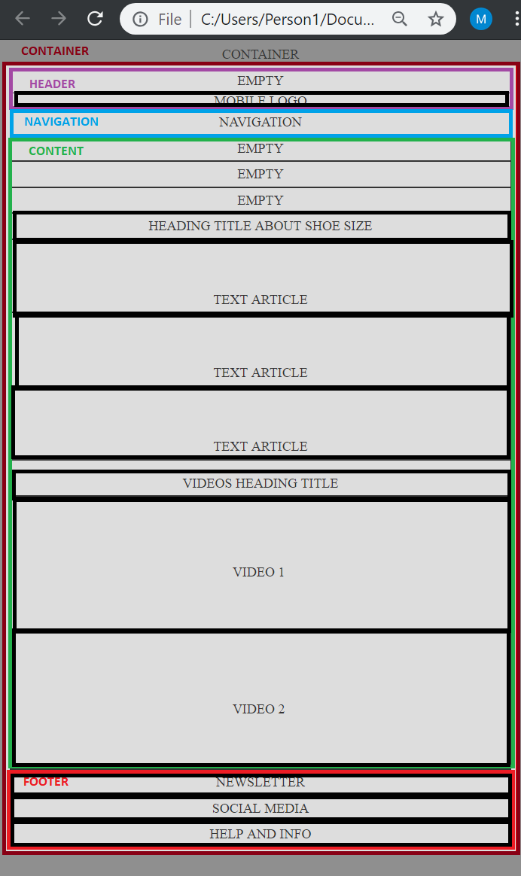

Figure 5 Sizes mobile wireframe

## Products page

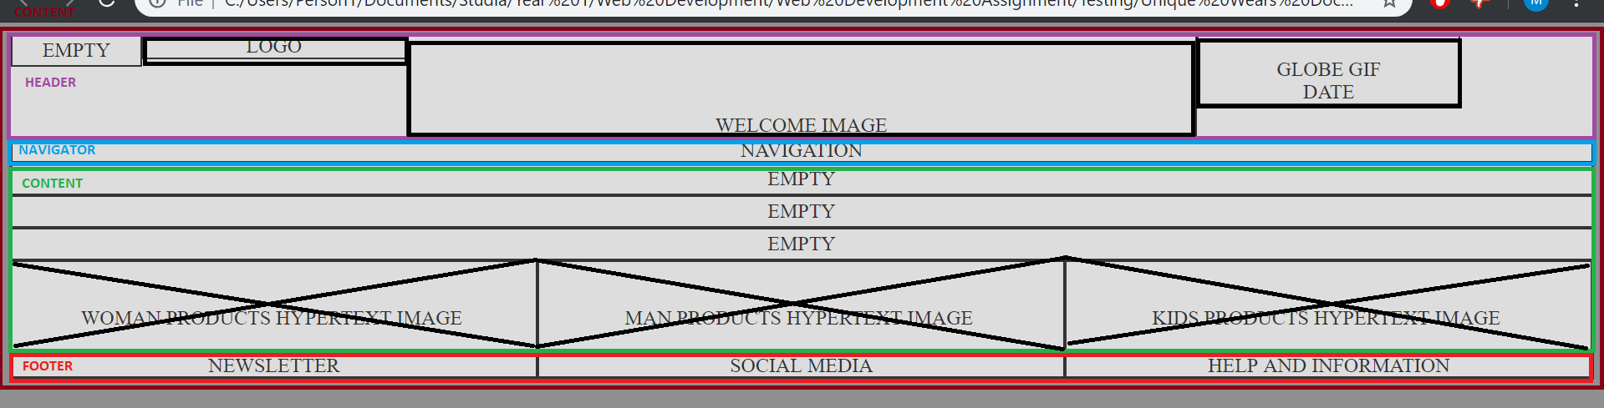

Figure 6 Products page wireframe

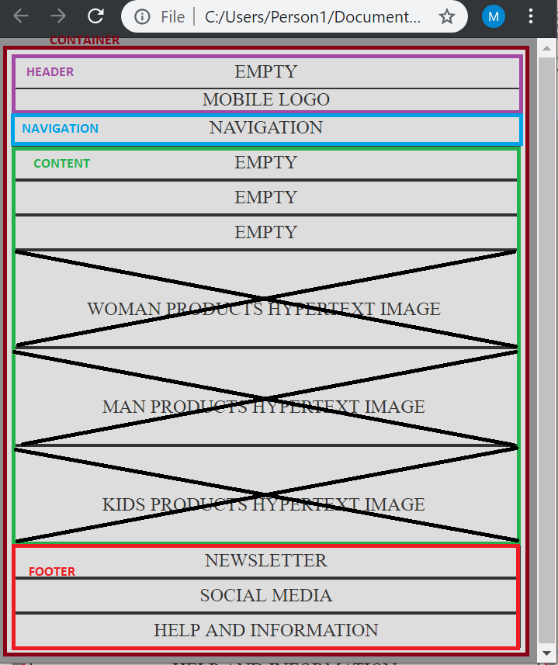

Figure 7 Products page mobile wireframe

On products page we can find three images with appropriate categories of shoes man, woman, and kids which has its own two subcategories boys and girls. So I designed the product gallery pages and product pages to be the same and code level different in values which allows to easy add another product and product page simply by coping division responsible for image and whole product page and linking them appropriately.

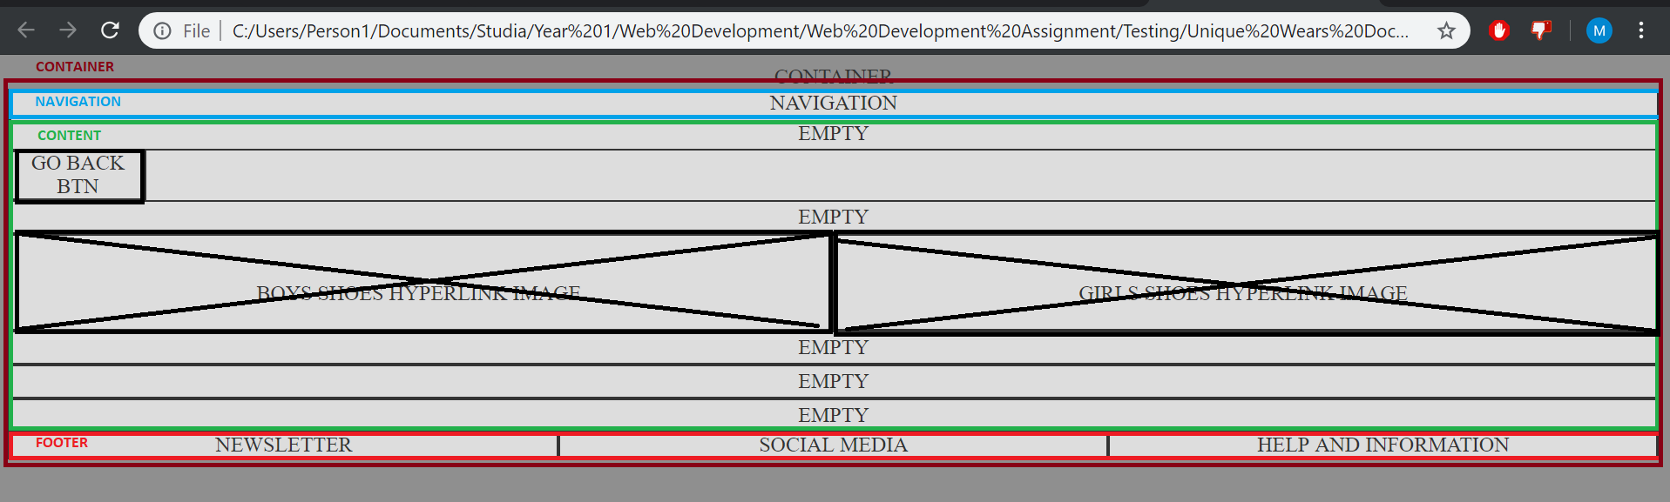

Figure 8 Kids page wireframe

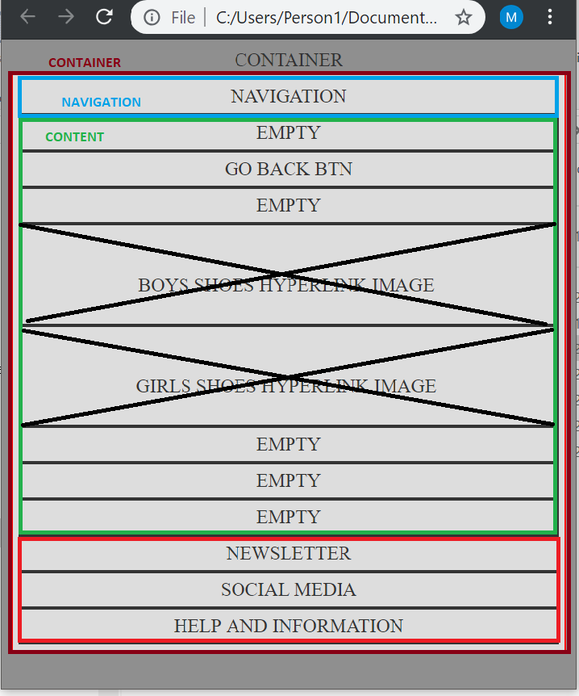

Figure 9 Kids page mobile wireframe

### Product gallery page

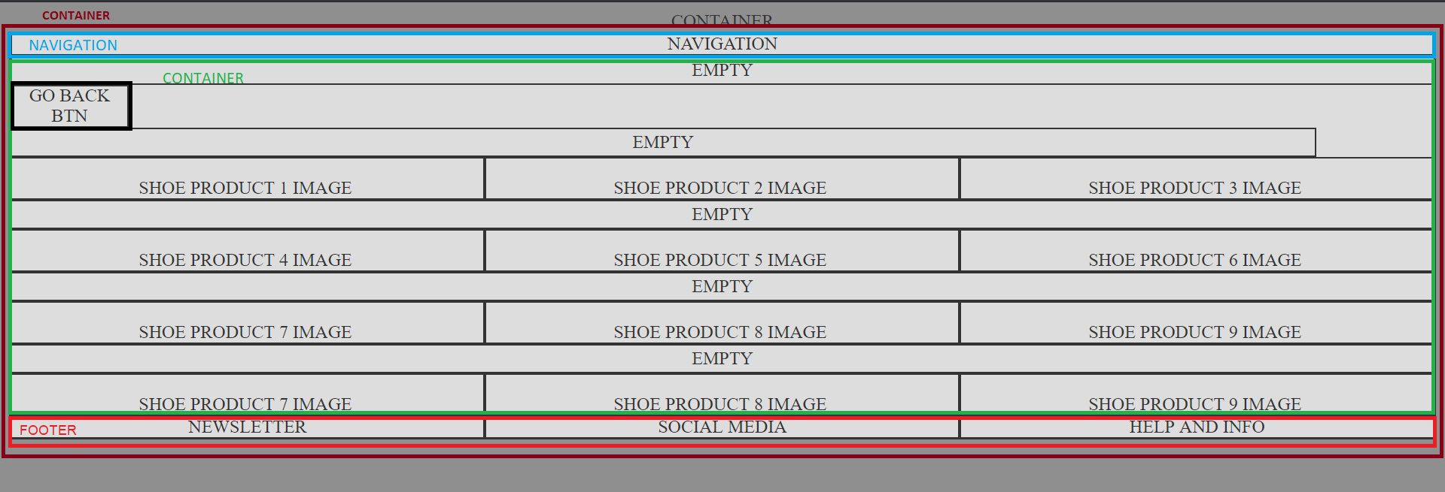

Figure 10 Product gallery wireframe

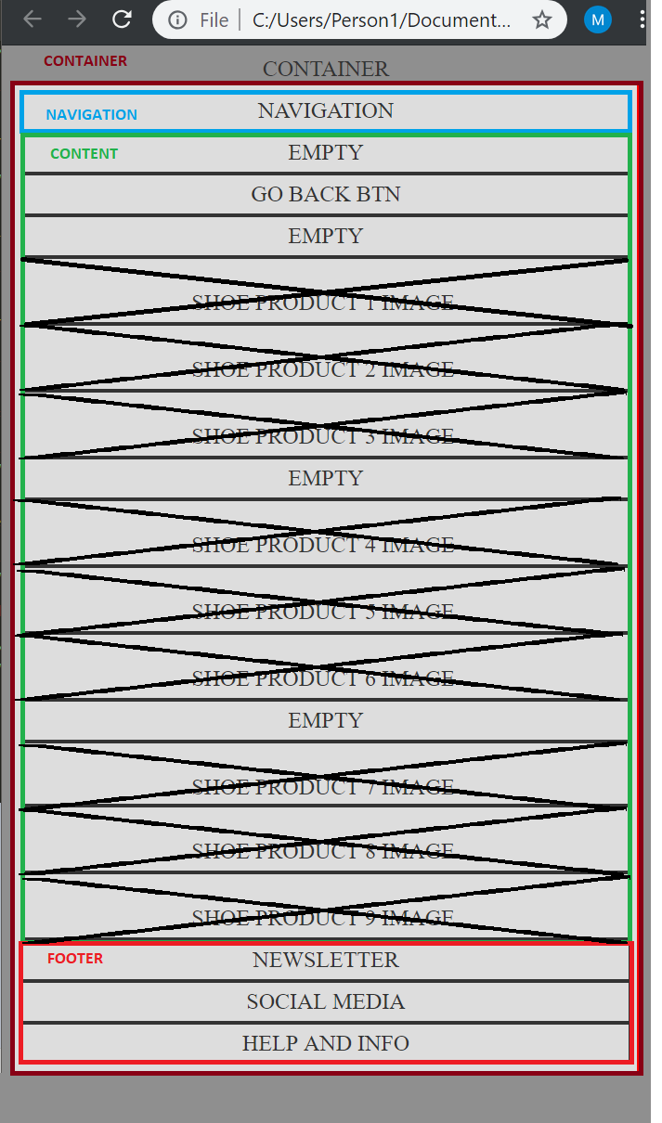

Figure 11 Product gallery mobile wireframe

Product gallery and product pages are slightly different from other pages. They don’t have header division just navigation on top, and they all have a go back button because they are not linked in the main navigation.

#### Product page

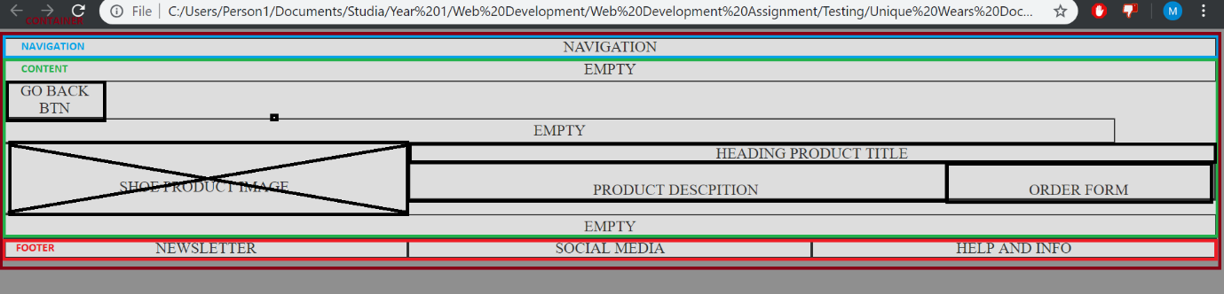

Figure 12 Product page wireframe

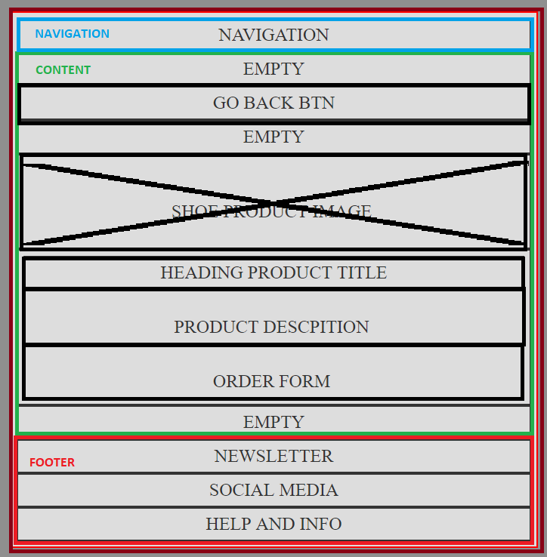

Figure 13 Product page mobile wireframe

## Contact page

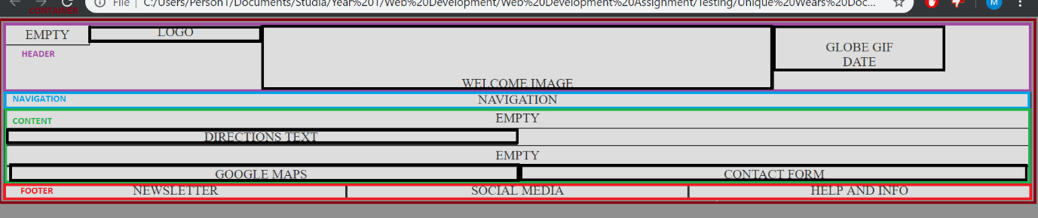

Figure 14 Contact page wireframe

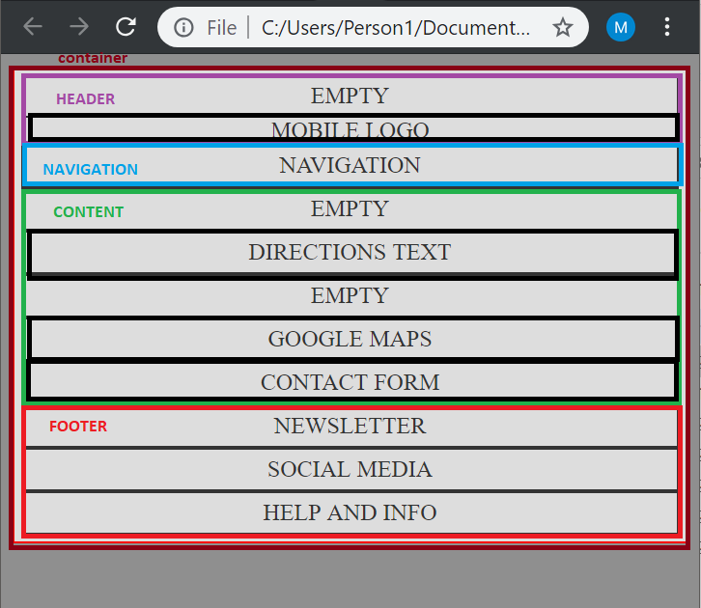

Figure 15 Contact page mobile wireframe

Contact page contains a <form> to solve client problem queries. It also has a <iframe> with google maps with our store location.

## Wholesale page

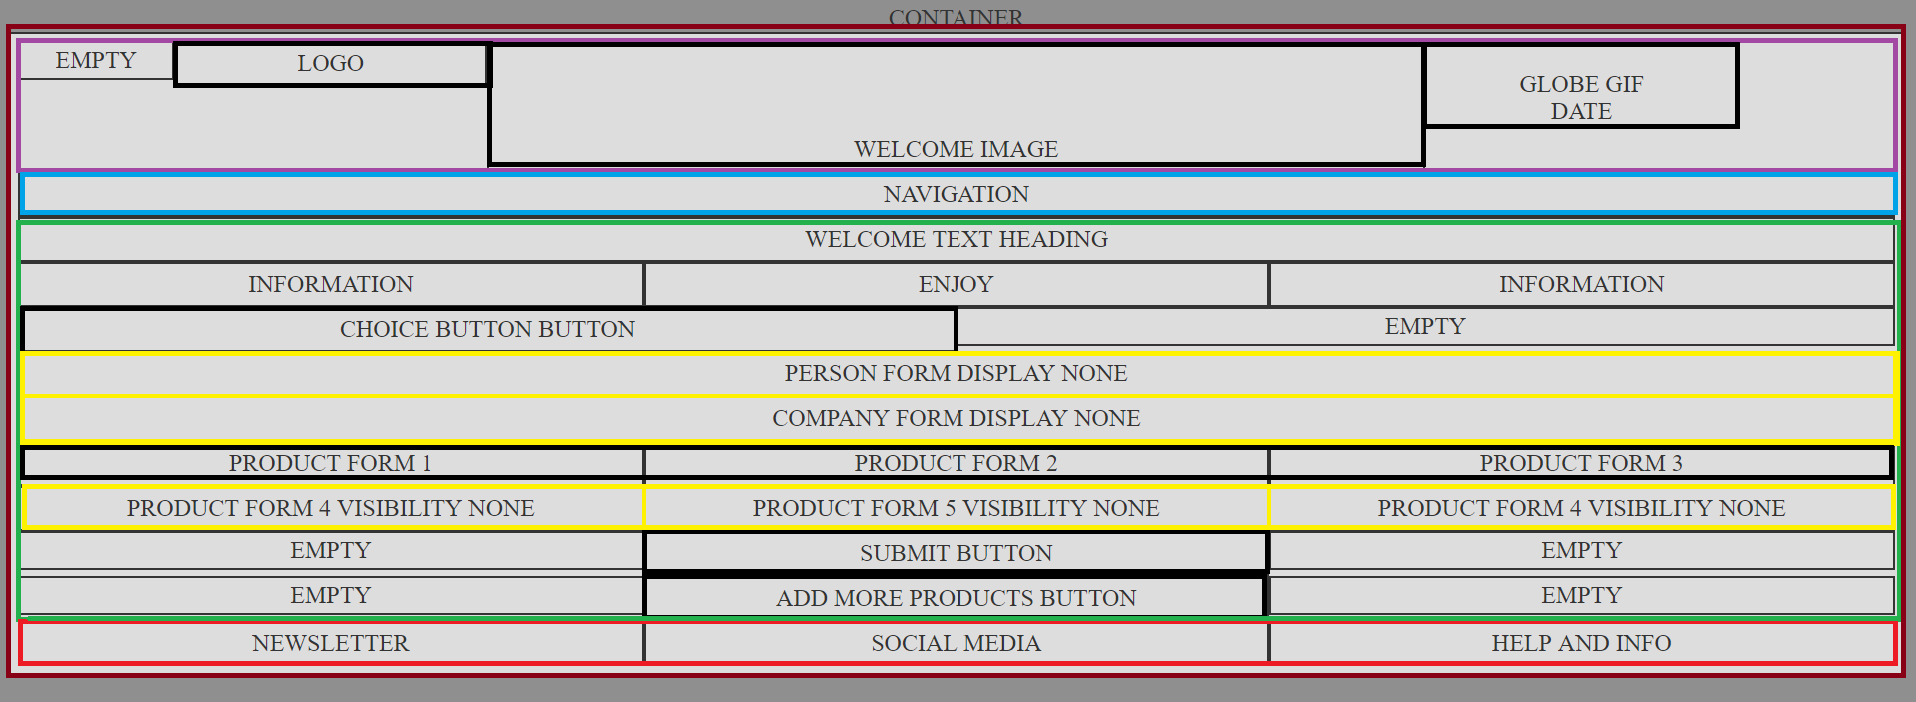

Figure 16 Whole sale wireframe

On wholesale page in yellow border are division which visibility is hidden from the view and revealed by clicking appropriate button.

## Colour schemes

Colour schemes where based on a logo image and I used page <http://www.colr.org/>

 Picture used for colour scheme.

# Development:

## Source codes and styles

I developed this site using Responsive Web Design in CSS. I divided the page into 12 equal columns and calculated space for each column and created a class [col-*] for each cases. Then I just needed add a class [col-*] with number from 1 to 12 to decide how much space will element occupy. Each [col-*] element needs to be put inside a row element and each row [col-*] elements should sum up 12. I then put every row in a <div> element called container.

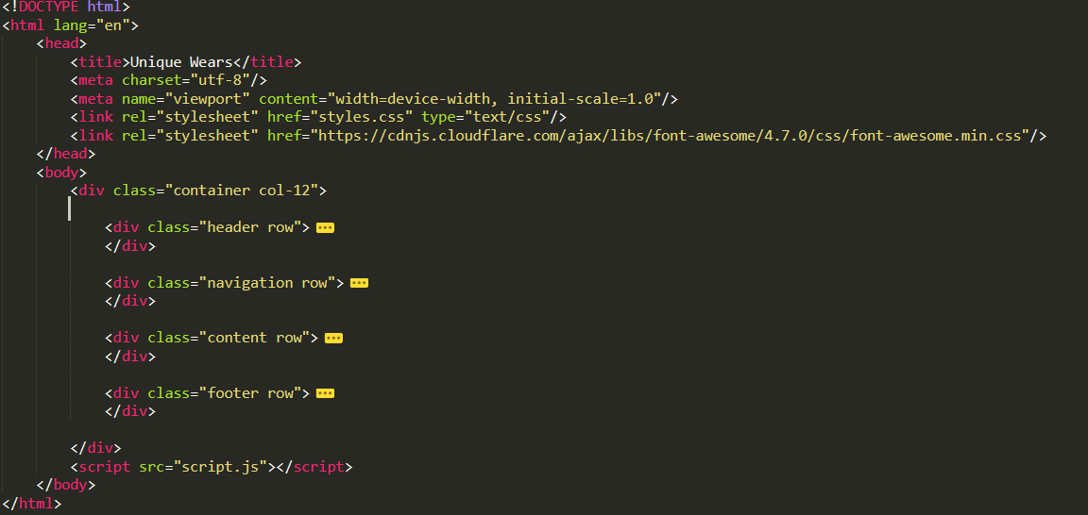

Figure 17

This figure shows header initialization setting up the view port, link the stylesheet, linking the jQuery, linking awesome fonts, setting the charset to utf-8 – lack of charset caused error during validation, but I didn’t do the screenshot. Awesome fonts are used for social media buttons.

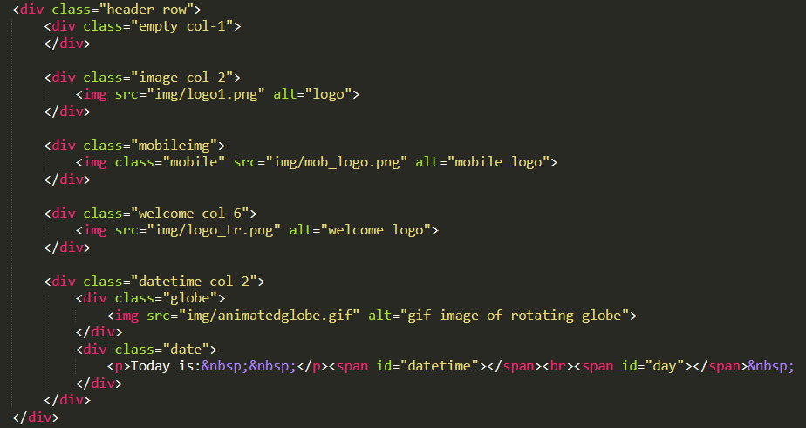

Figure 18 Header row

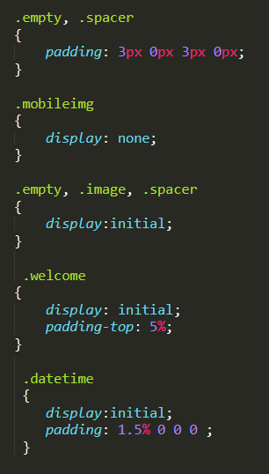

Figure 19 header style desktop

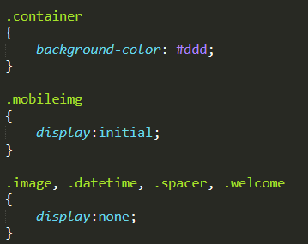

Figure 20 header style mobile

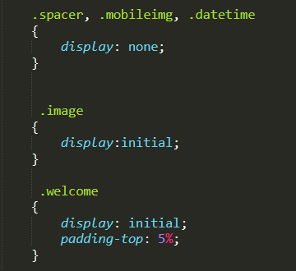

Figure 21 header style tablet



Figure 22 header

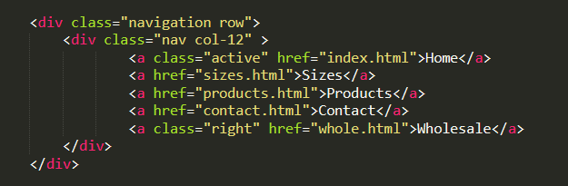

Figure 23 Navigation row

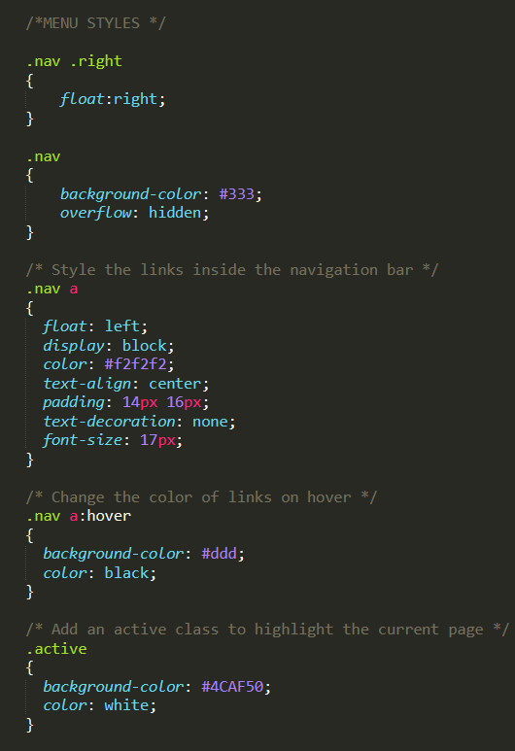

Figure 24 Navigation style desktop

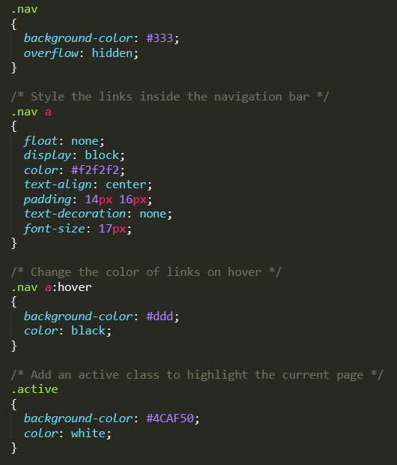

Figure 25 navigation style mobile

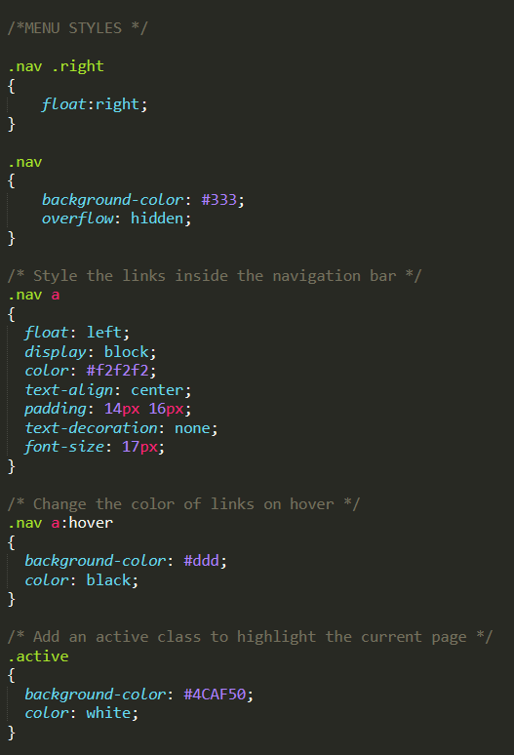

Figure 26 navigation style tablet



Figure 27 navigation bar



Figure 28 navigation bar different page active

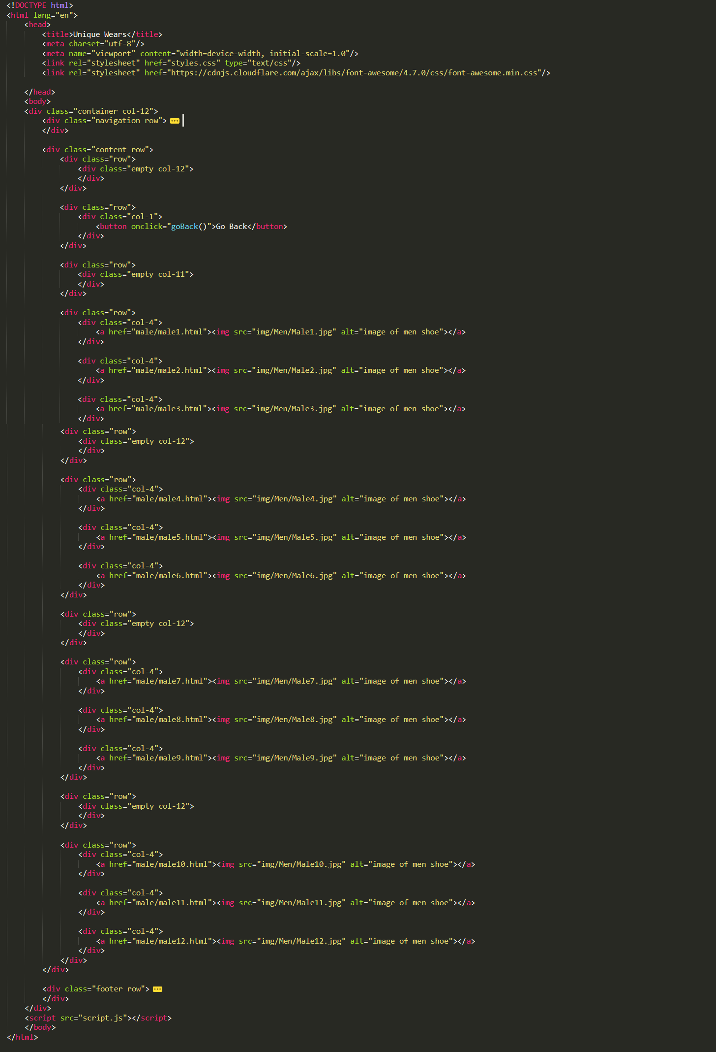

Figure 29 men gallery page

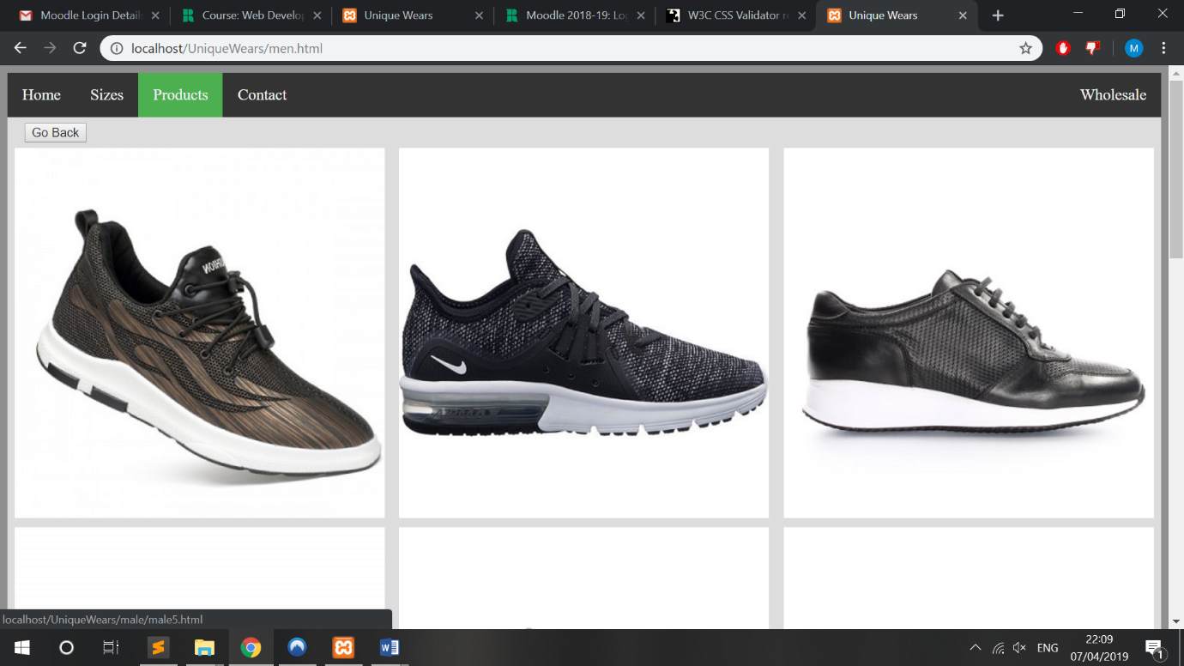

Figure 30 men product page

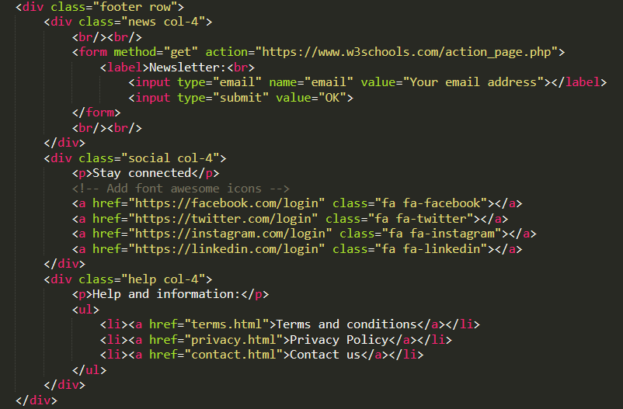

Figure 31 Footer row

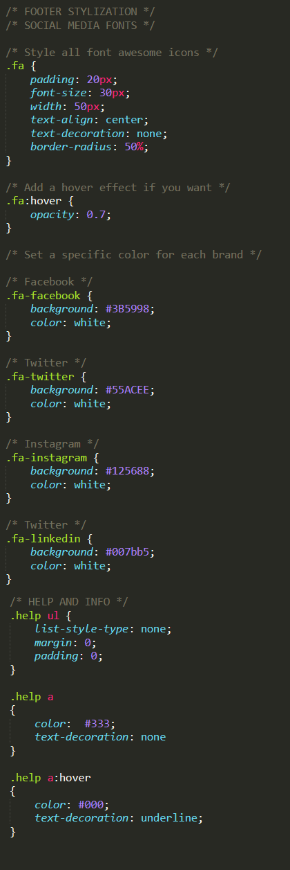

Figure 32 footer style



Figure 33 footer

## Breakpoints

Breakpoints are used to show different formatting on different screen sizes based on a viewport

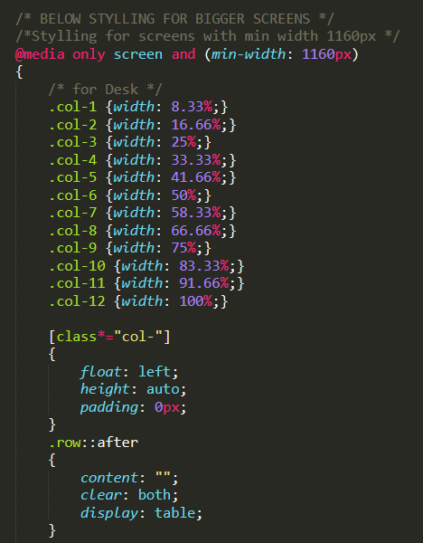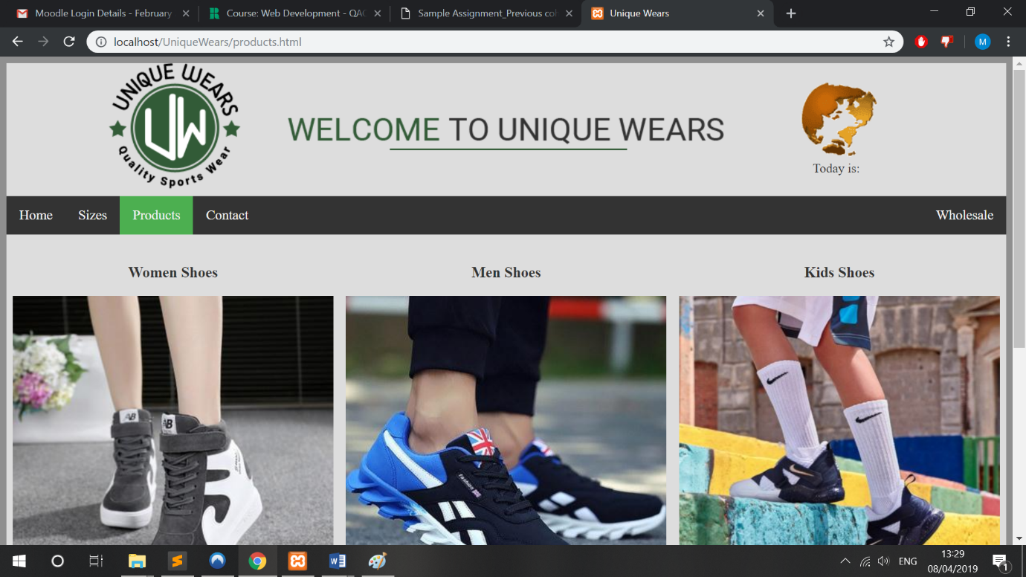

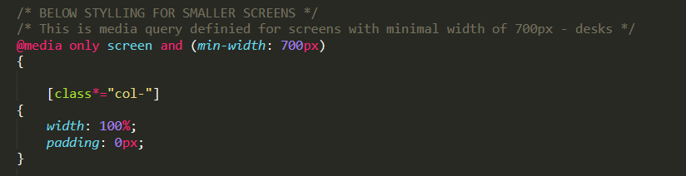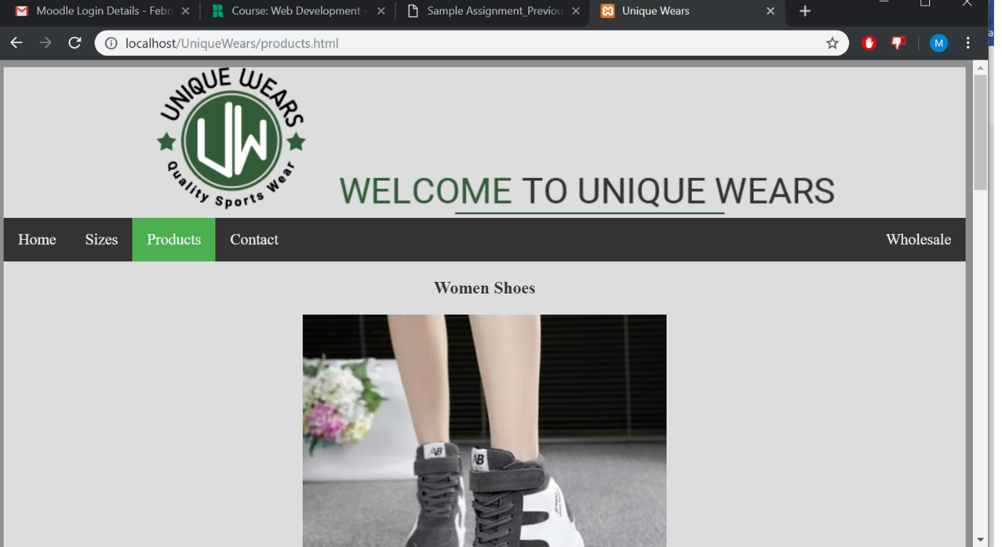

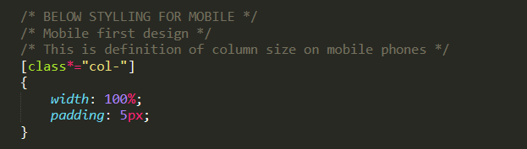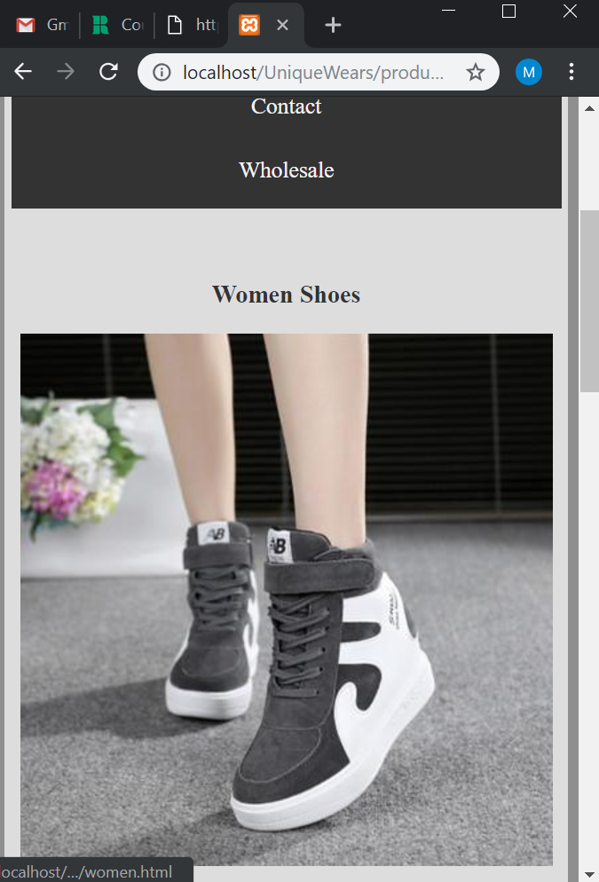

# *Testing* and validation:

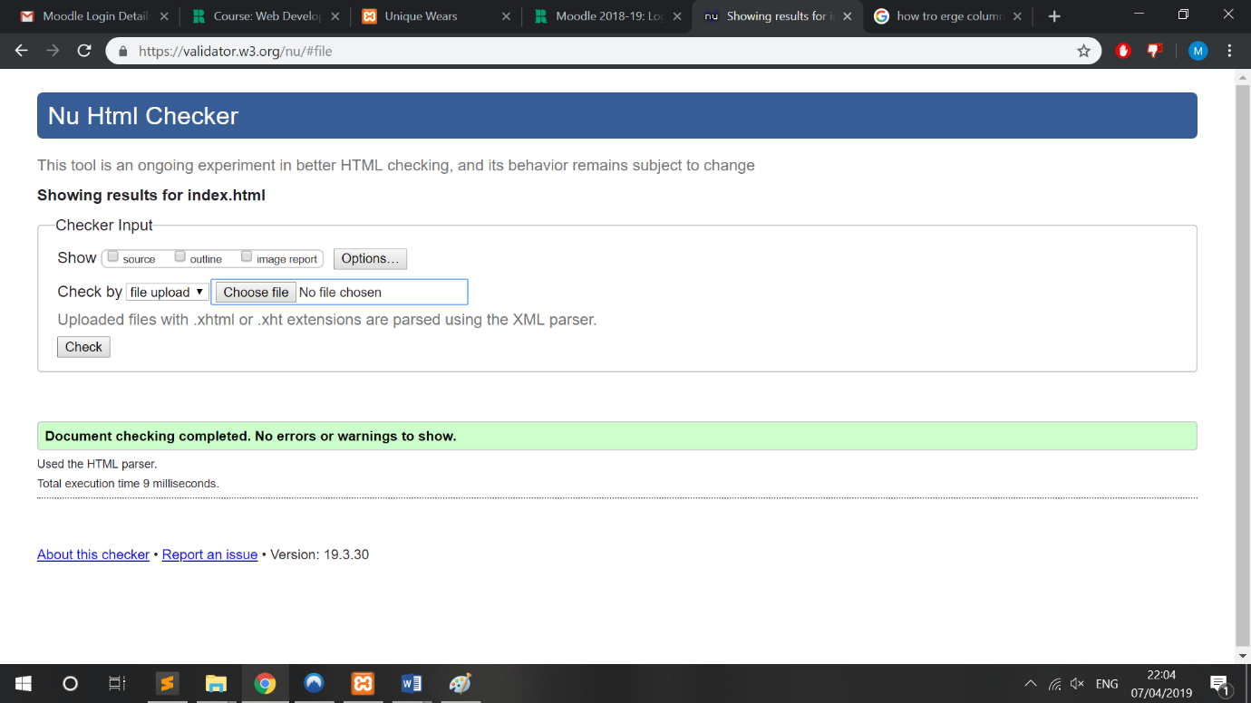

Figure 34

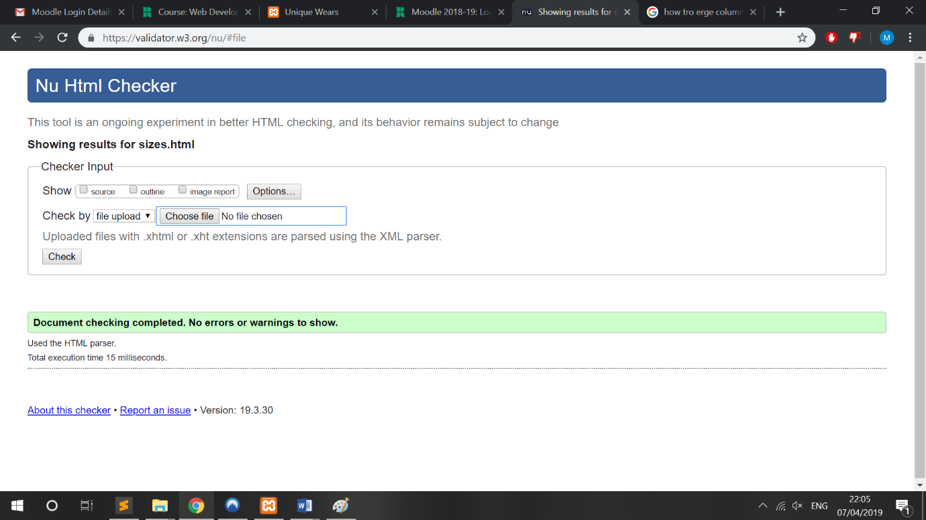

Figure 35

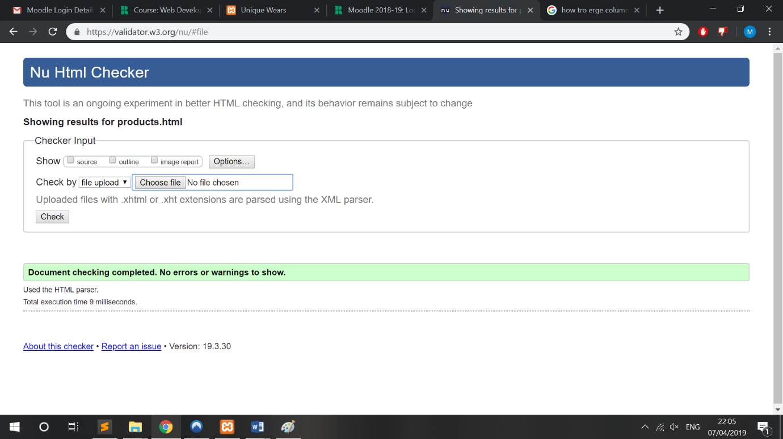

Figure 36

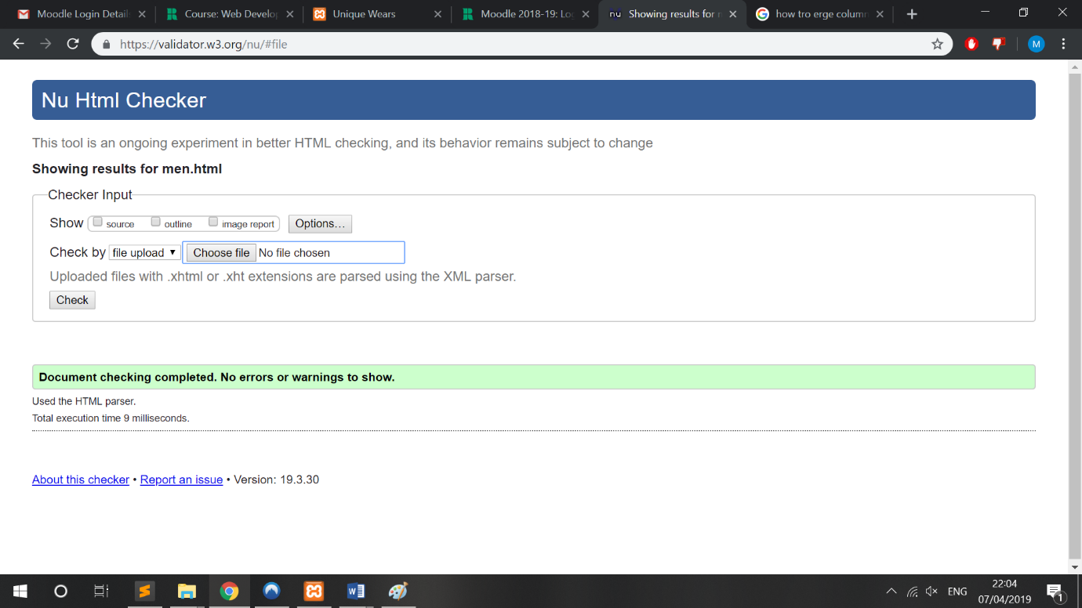

Figure 37

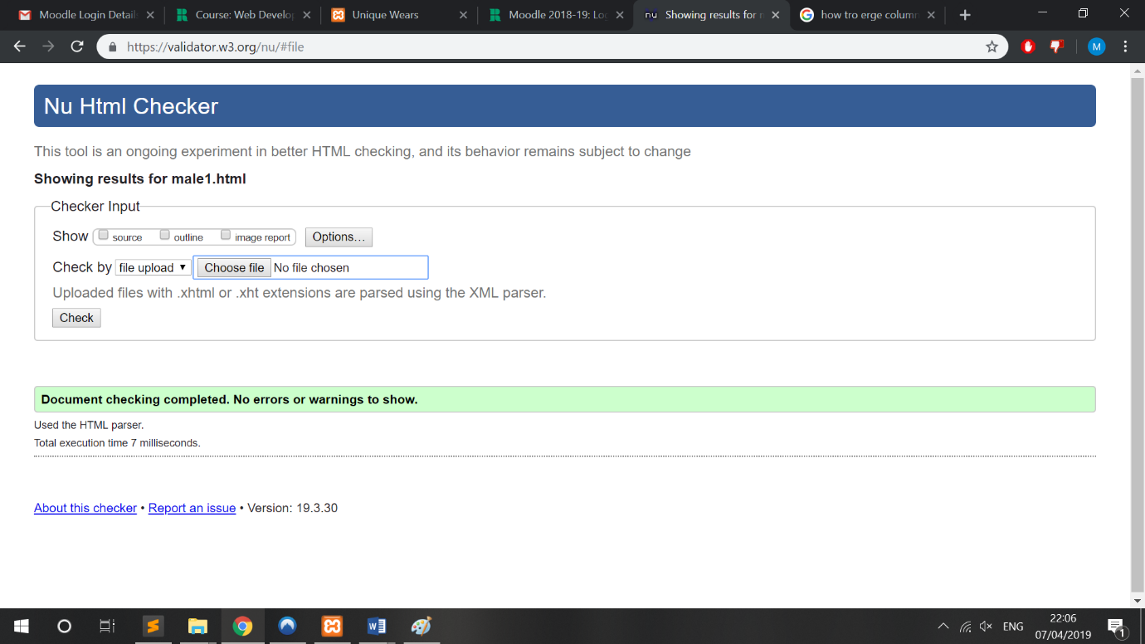

Figure 38

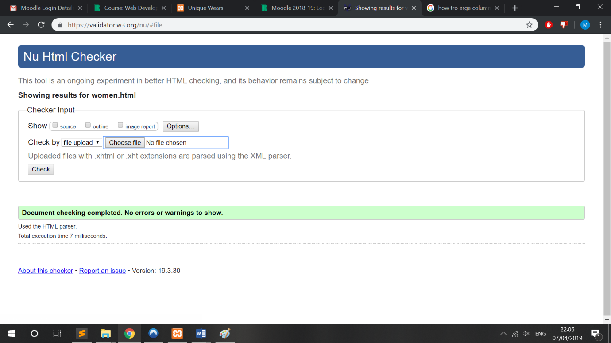

Figure 39

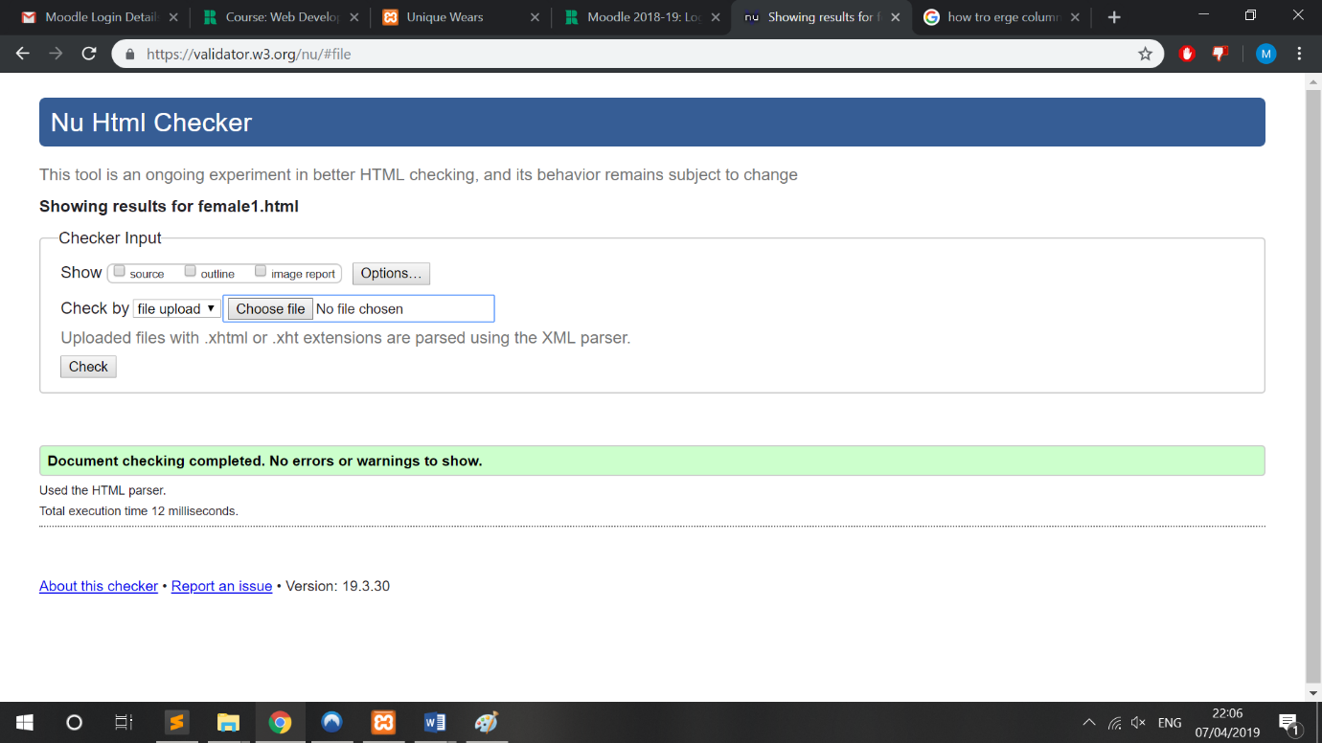

Figure 40

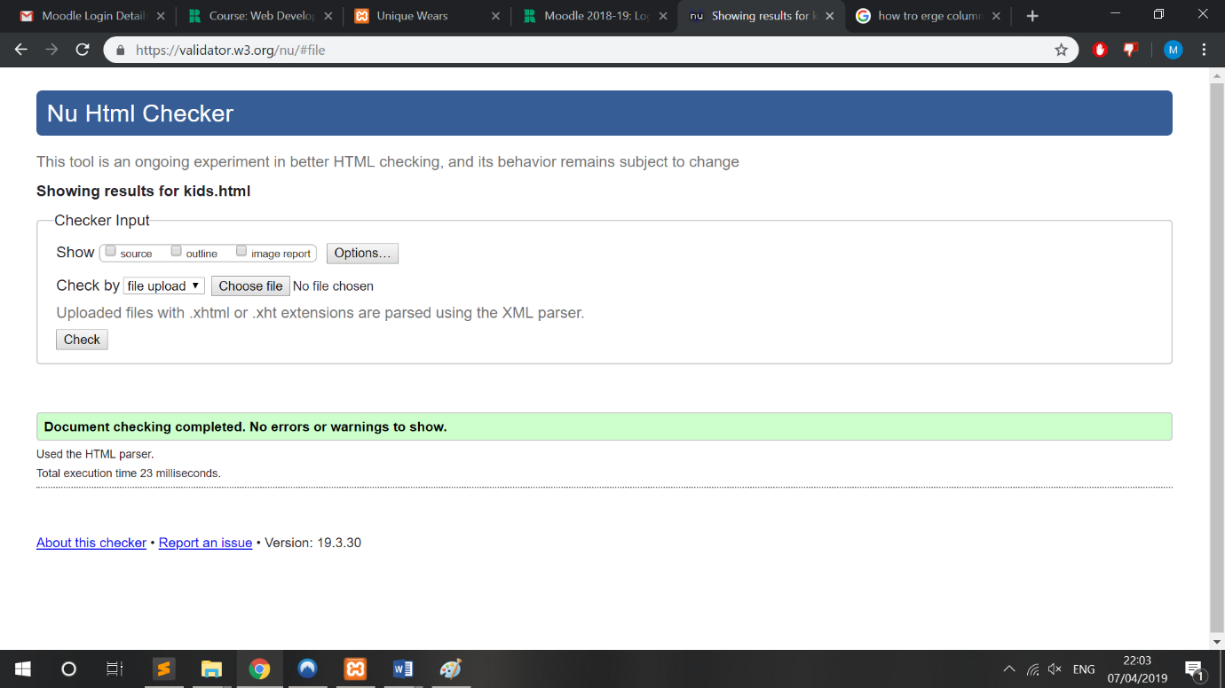

Figure 41

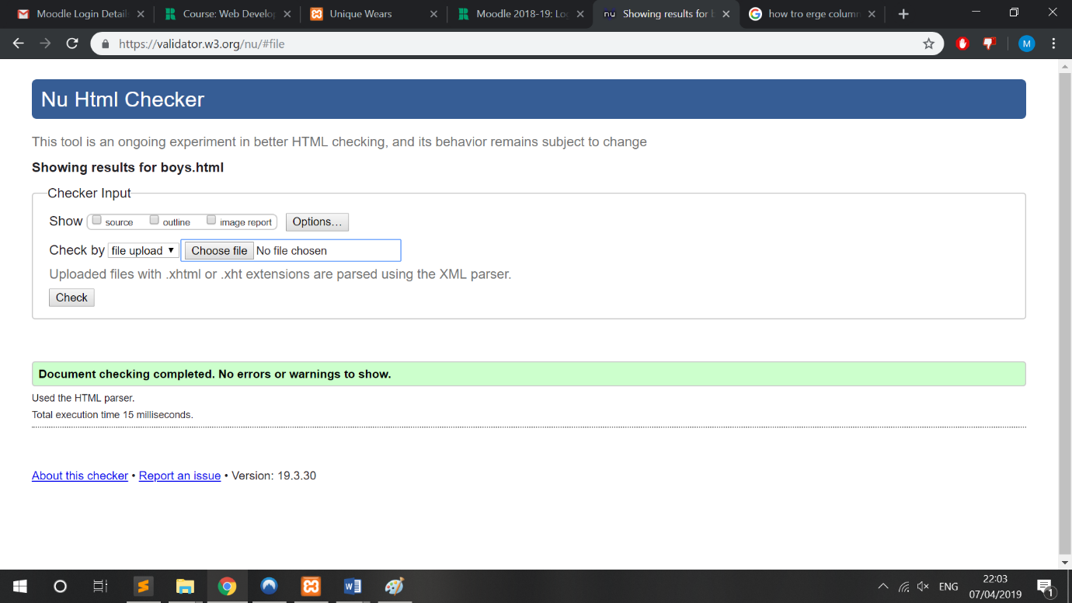

Figure 42

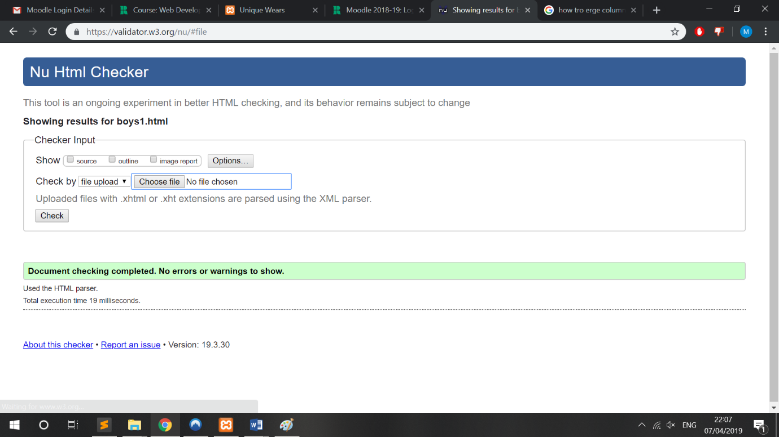

Figure 43

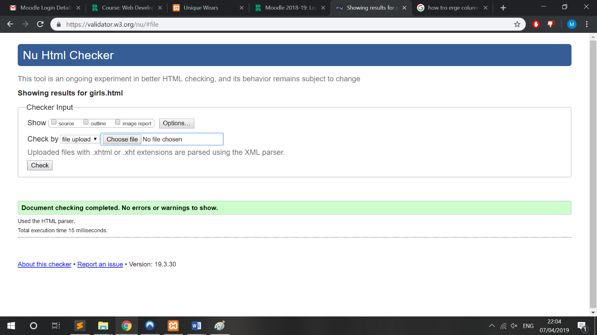

Figure 44

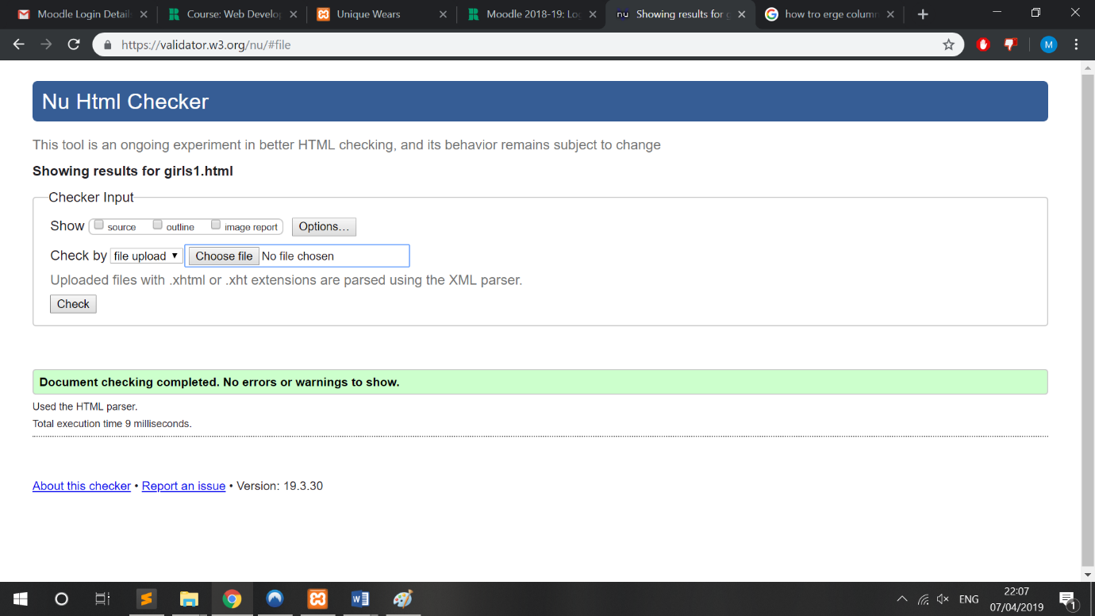

Figure 45

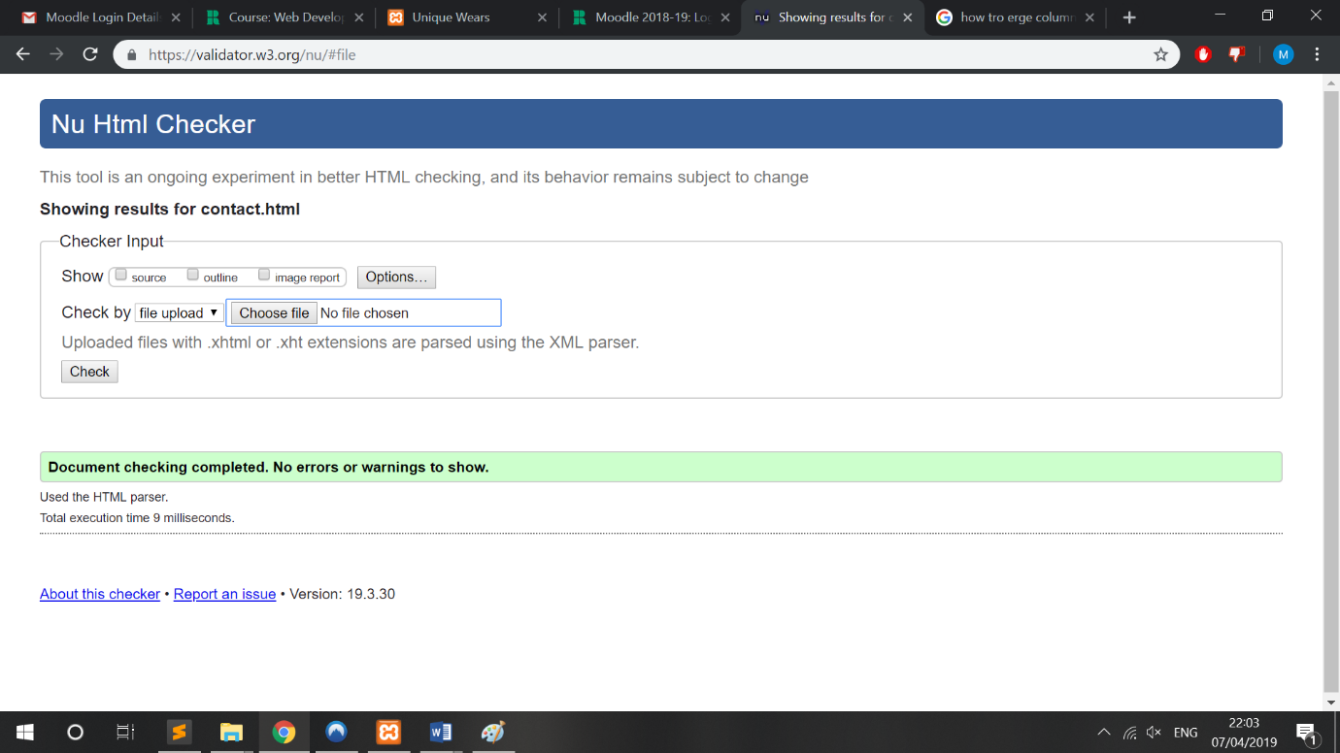

Figure 46

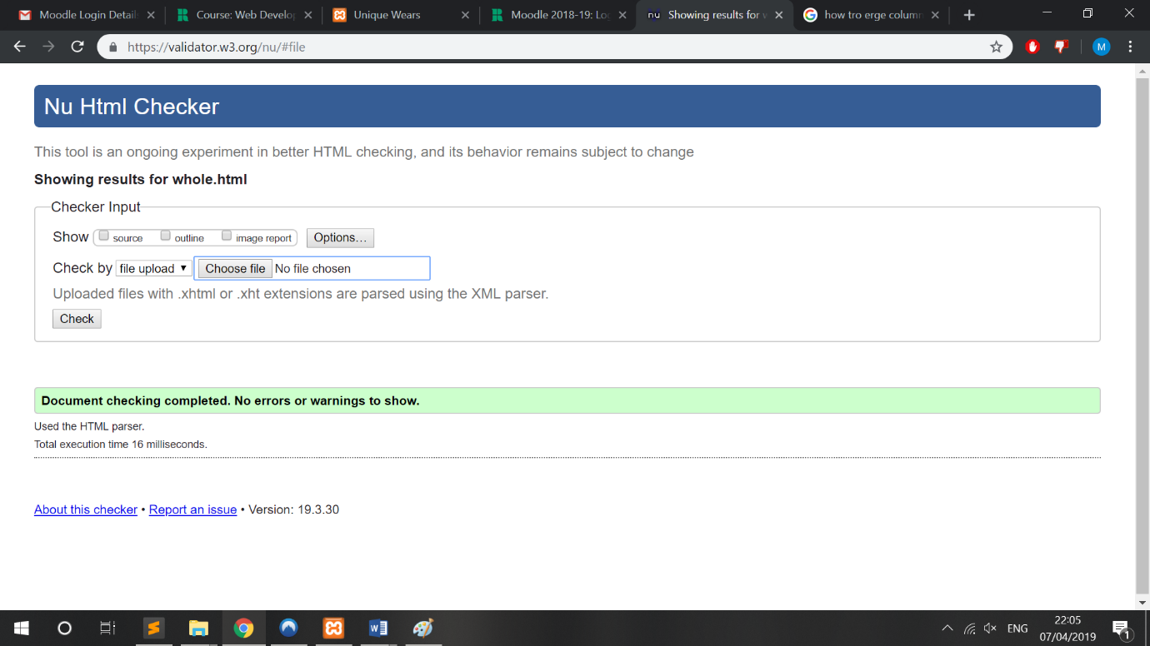

Figure 47

## XAMMP server installation process

Below are screenshots of XAMMP installation and website deployment.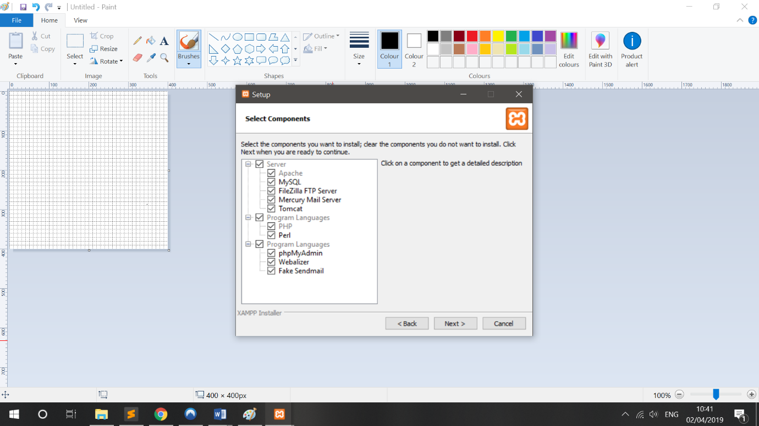

Figure 48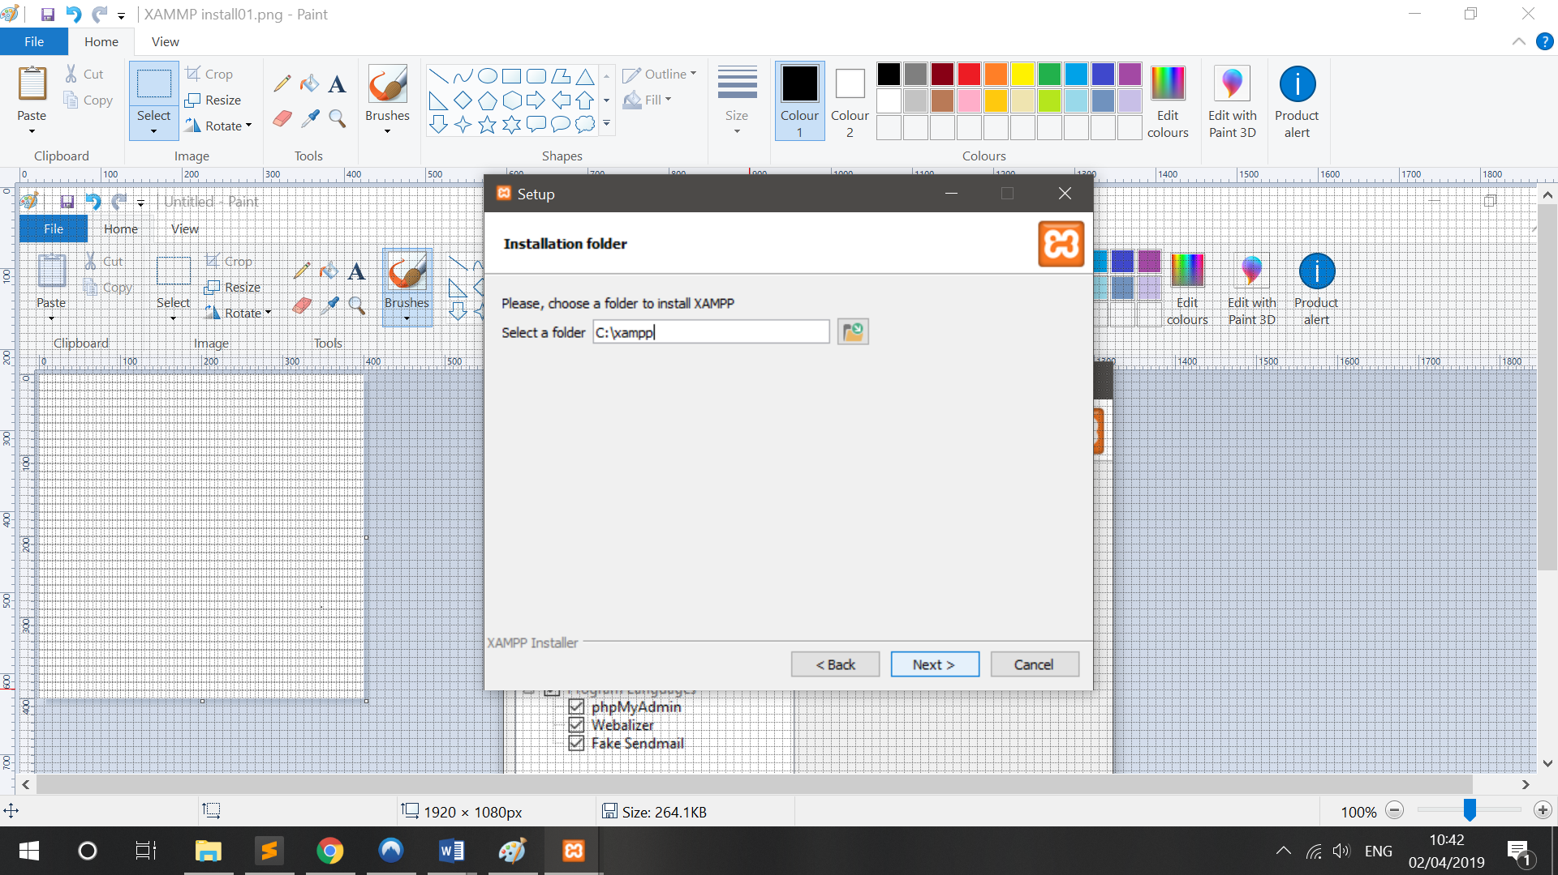

Figure 49

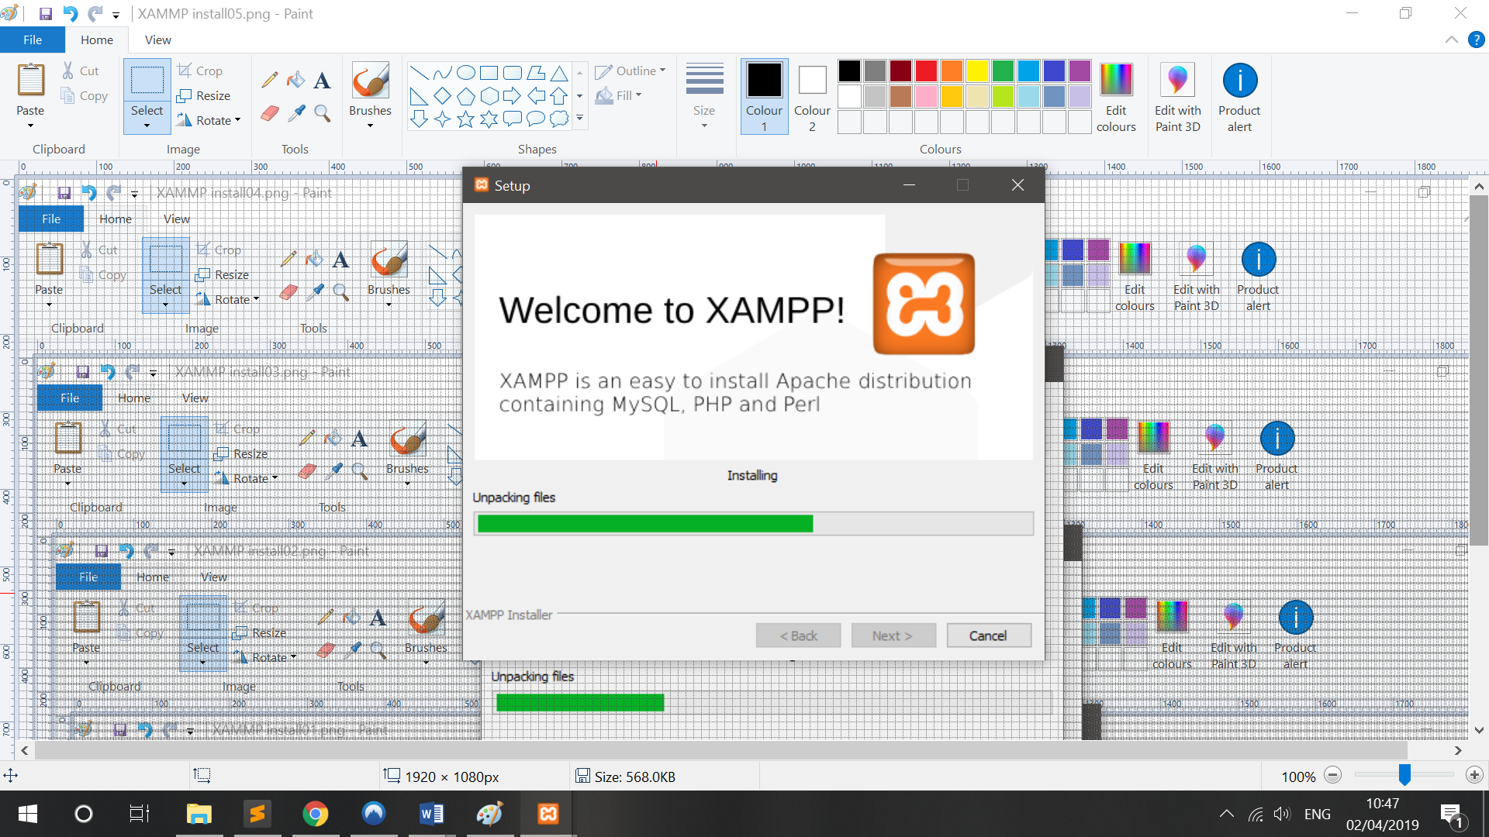

Figure 50

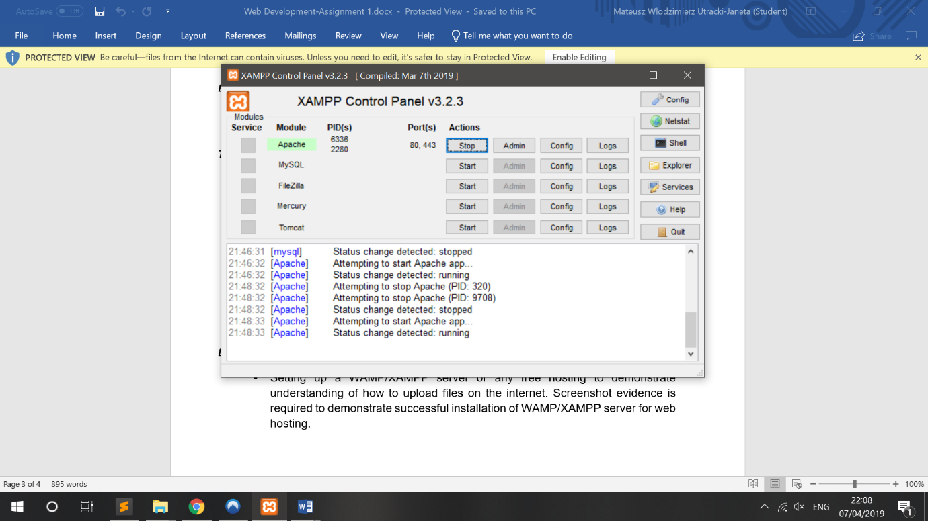

Figure 51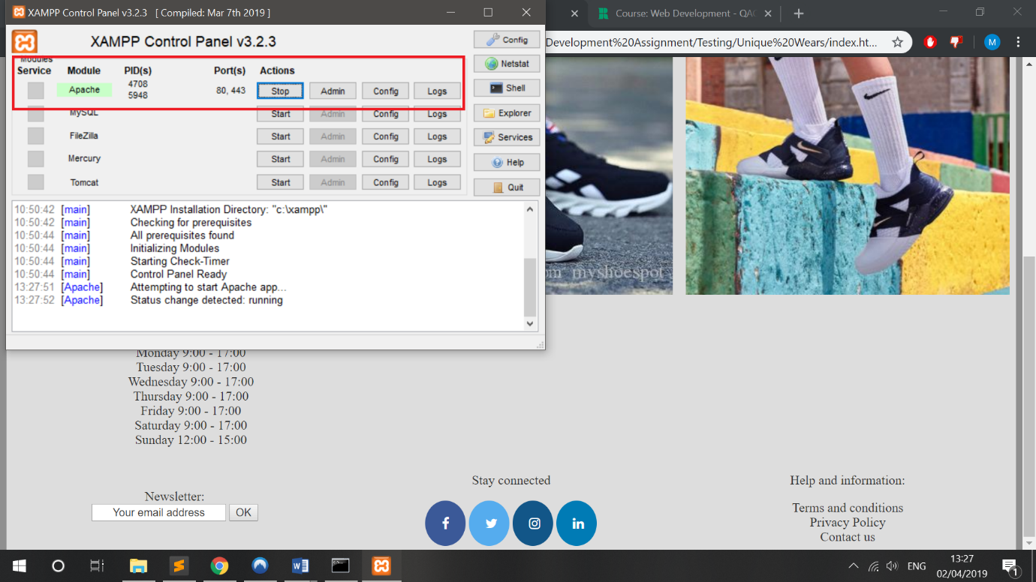

Figure 52

## Page running on server

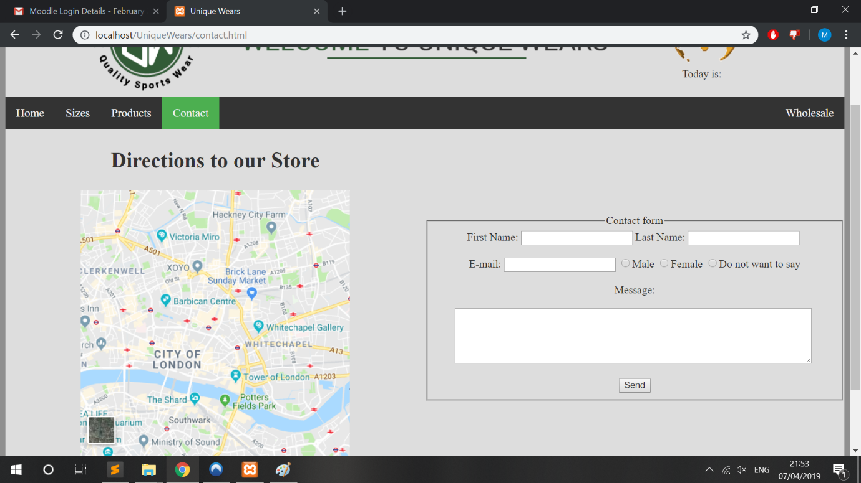

Figure 53 contact page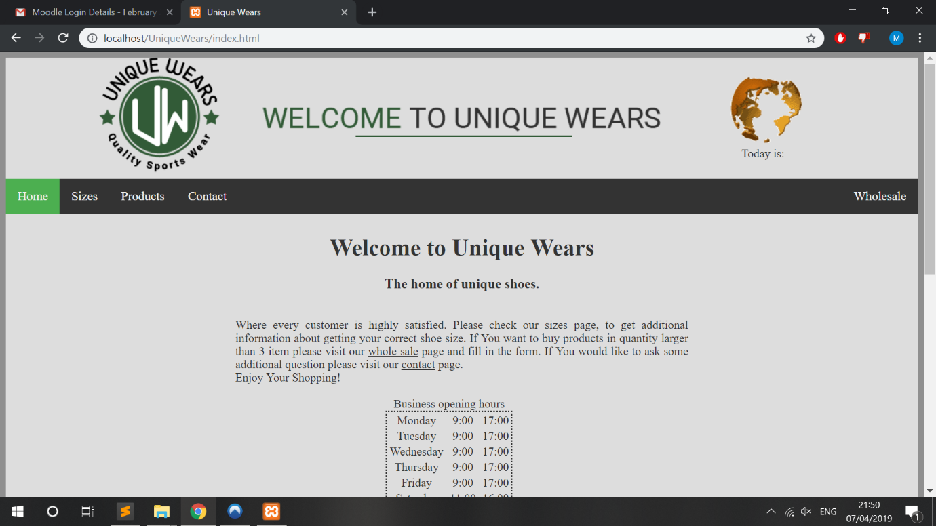

Figure 54 home page

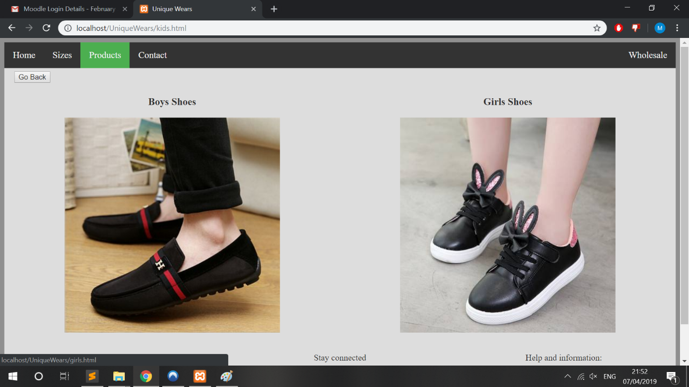

Figure 55 kids page

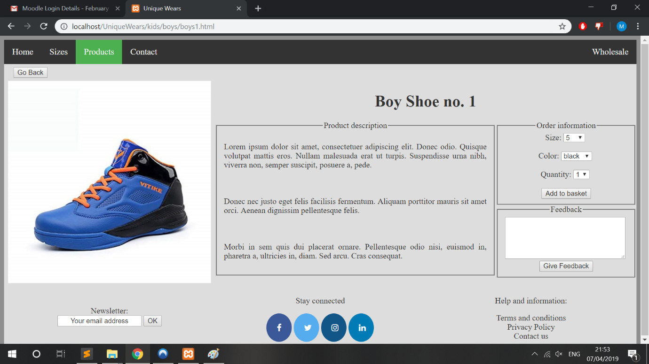

Figure 56 boys product page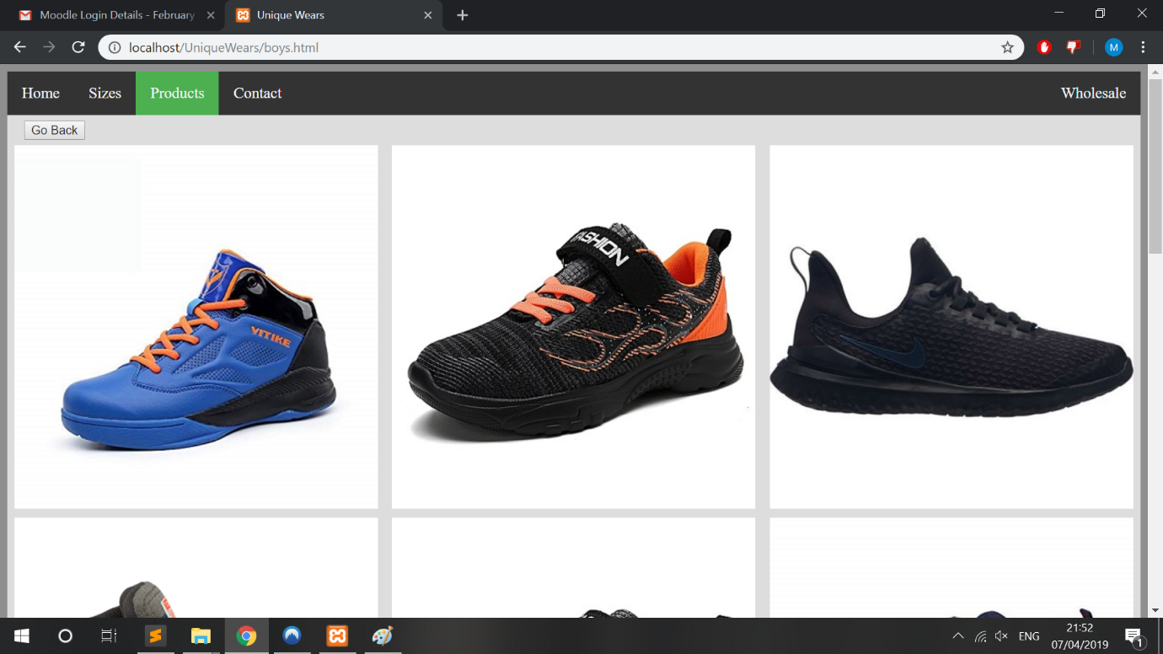

Figure 57 boys gallery page

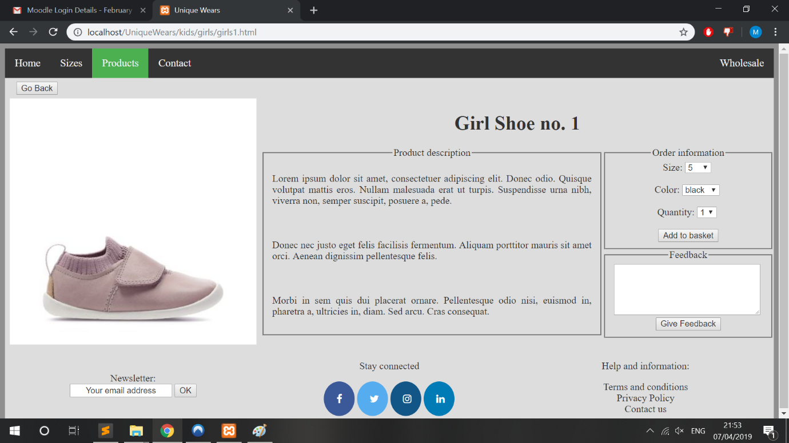

Figure 58 girls product page

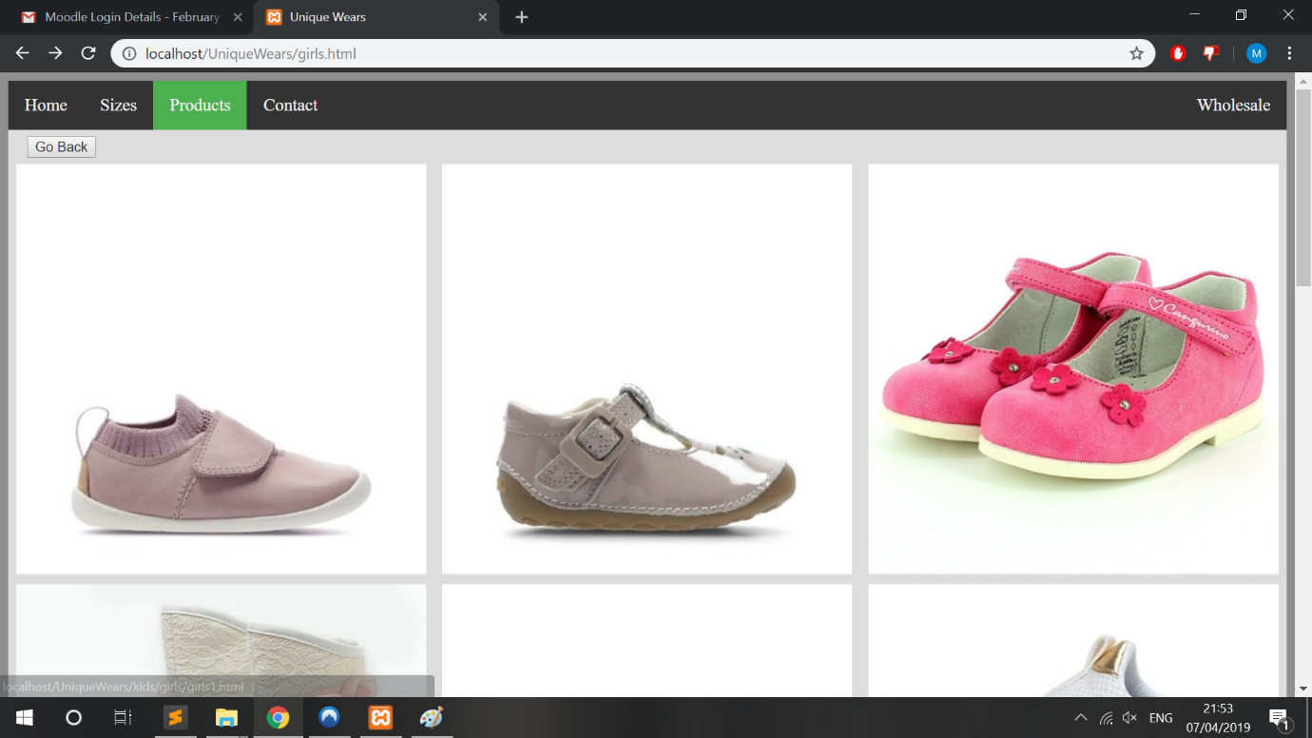

Figure 59 girls gallery page

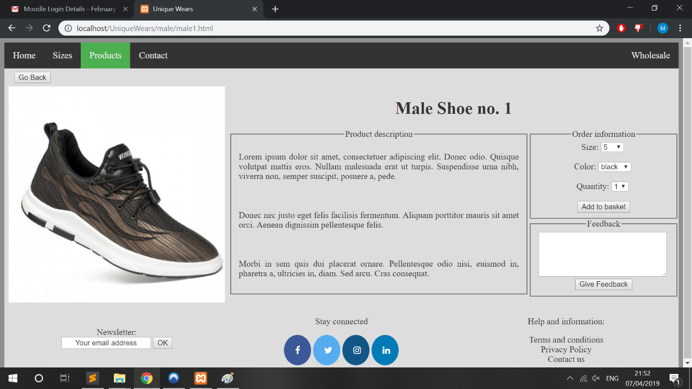

Figure 60 man product page



Figure 61 man gallery page

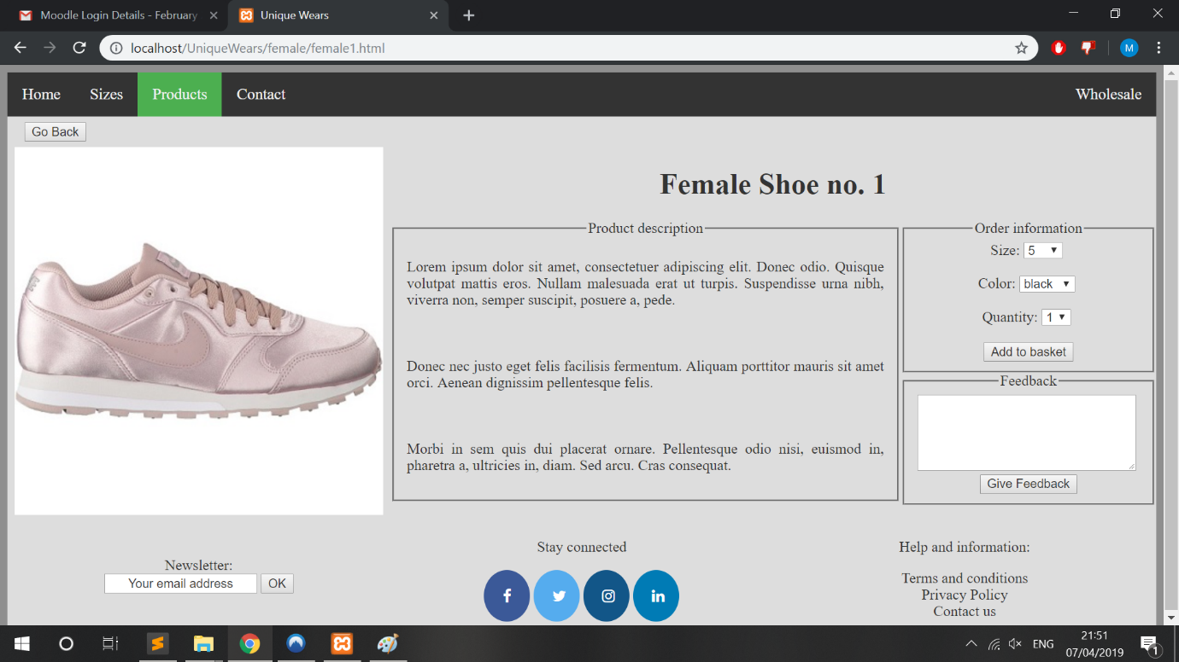

Figure 62 female shoe product page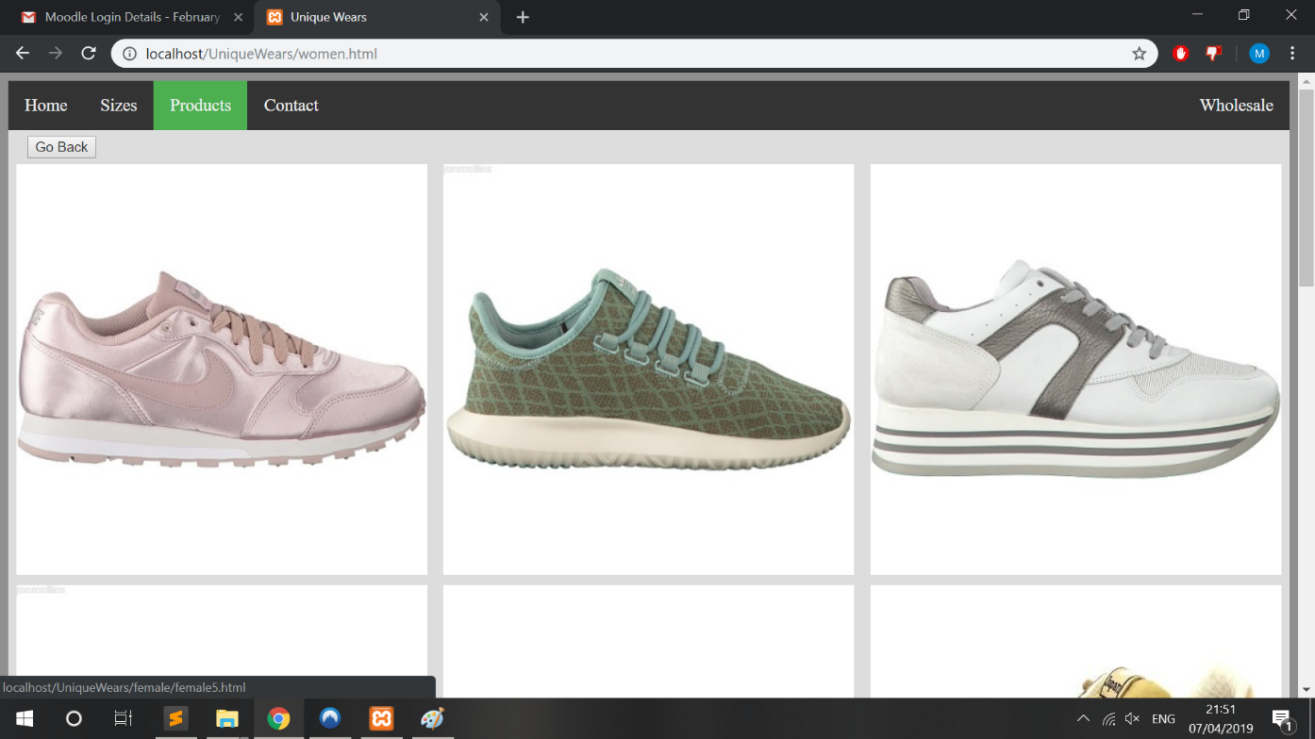

Figure 63 Women gallery page

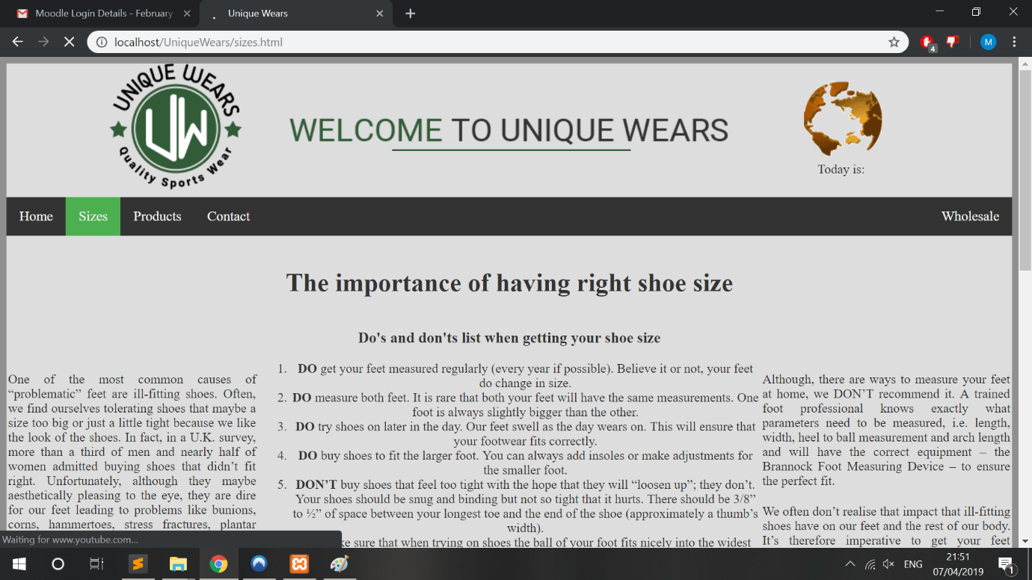

Figure 64 sizes page

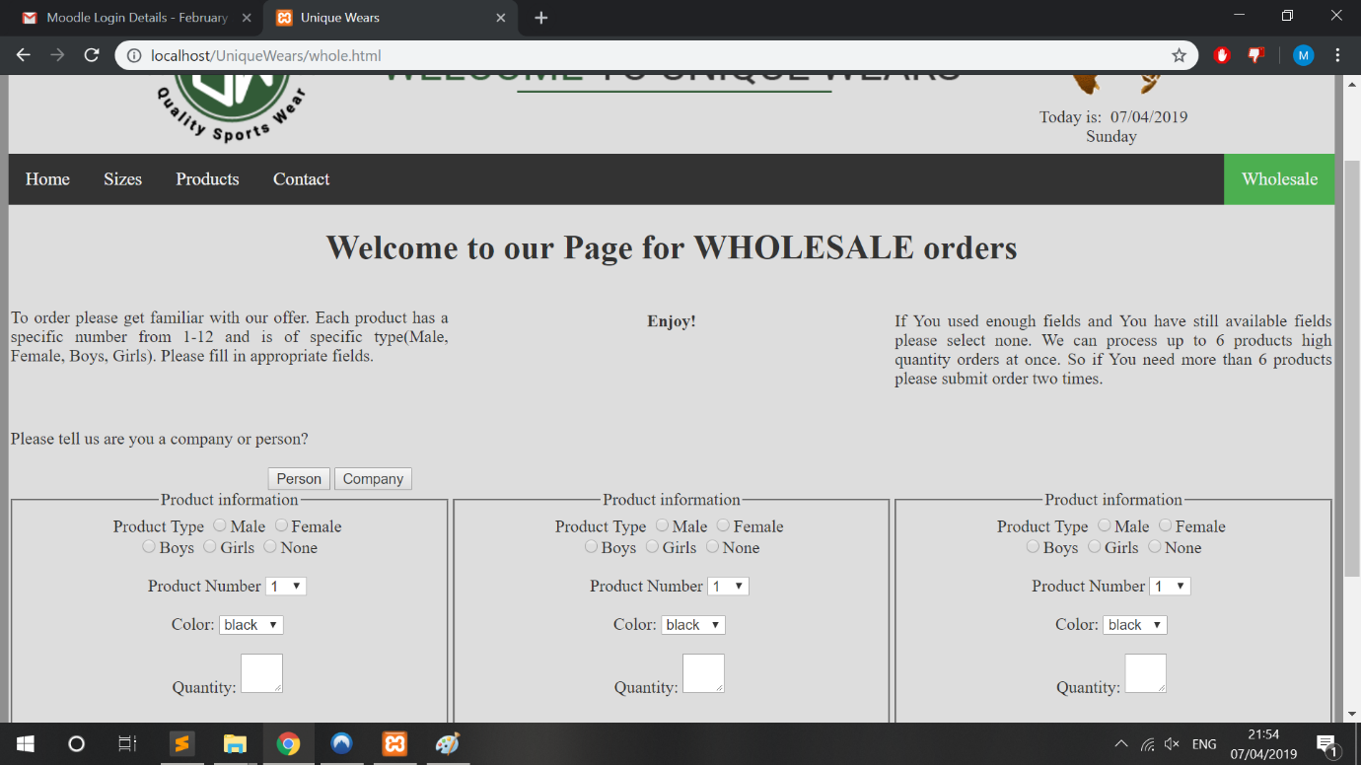

Figure 65 wholesale page

## Submission buttons test

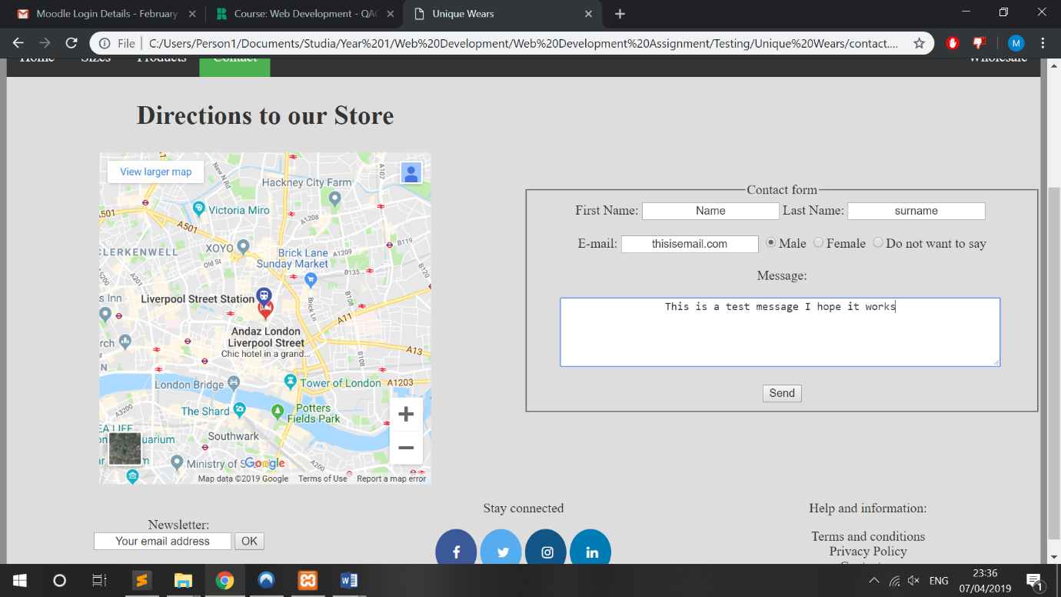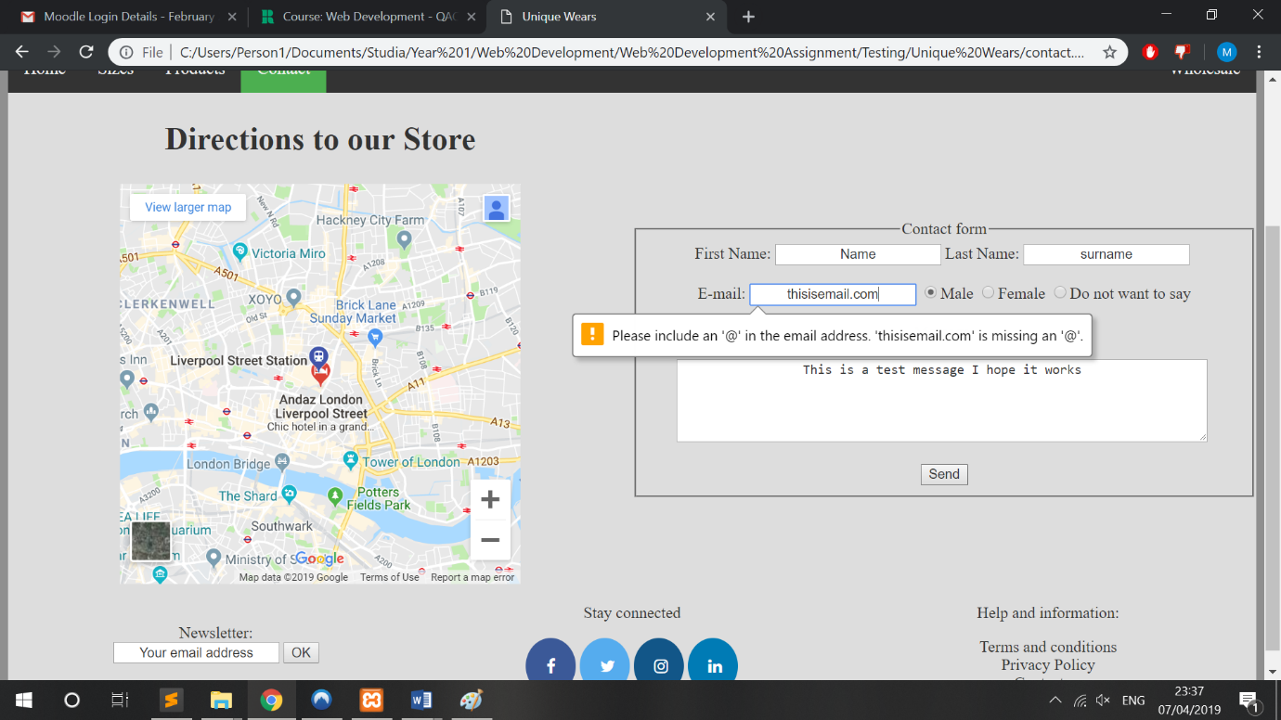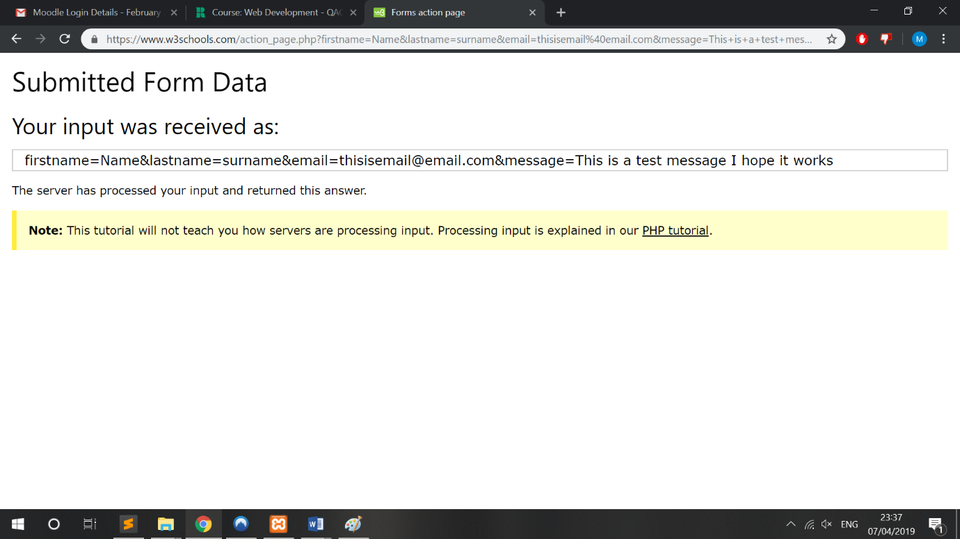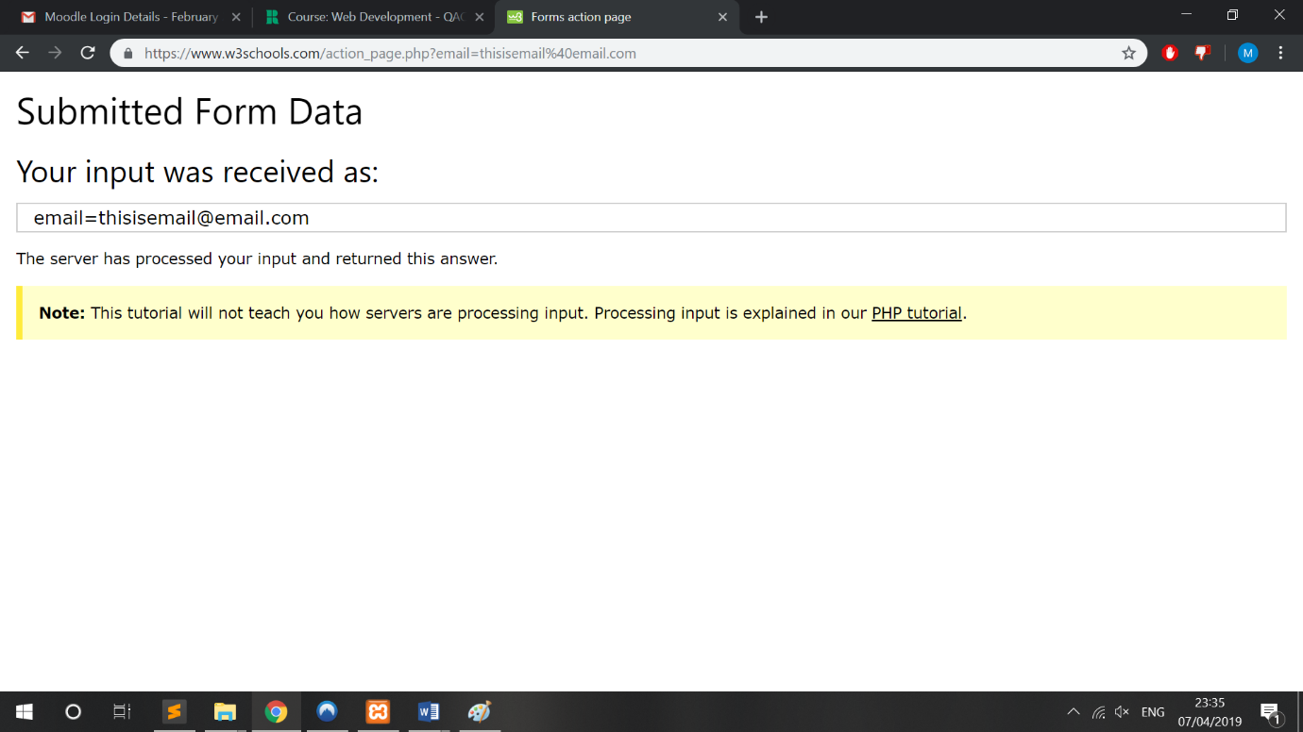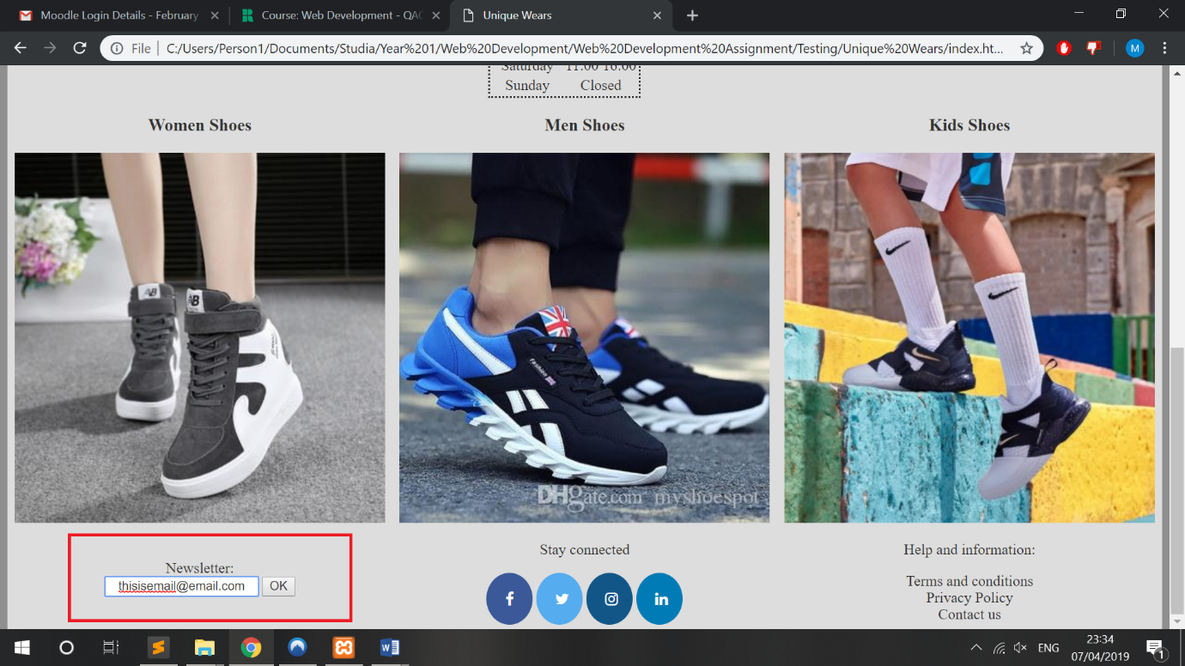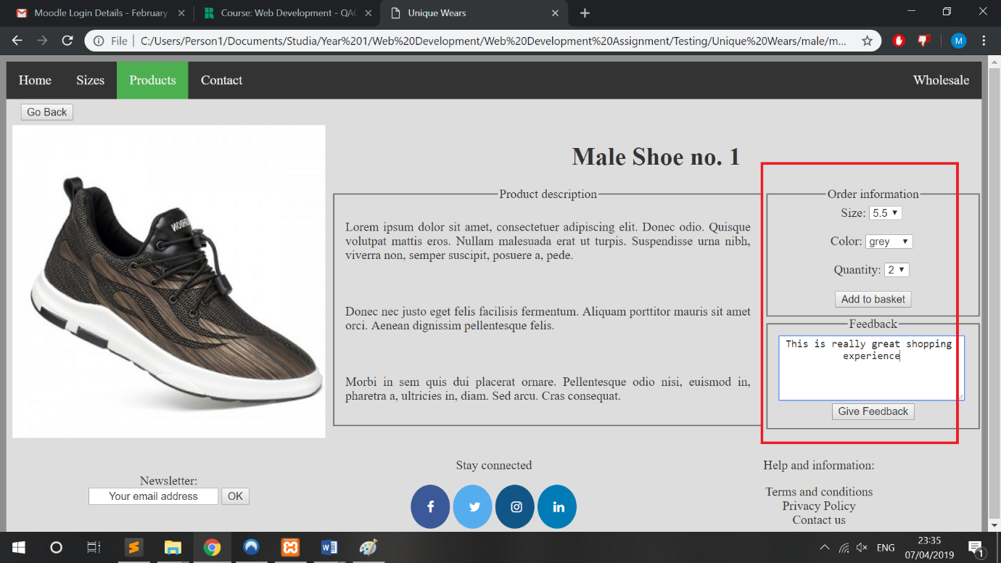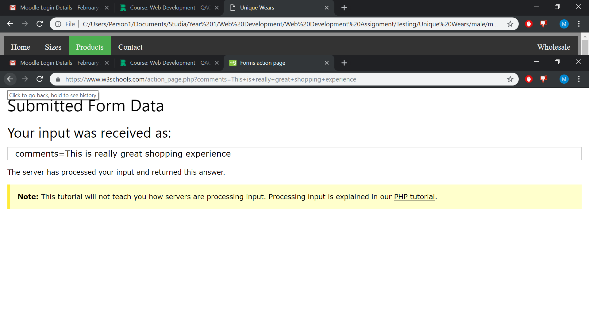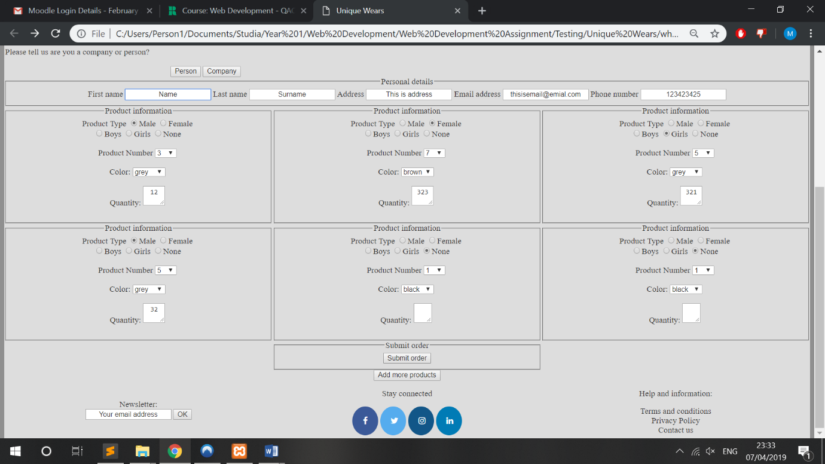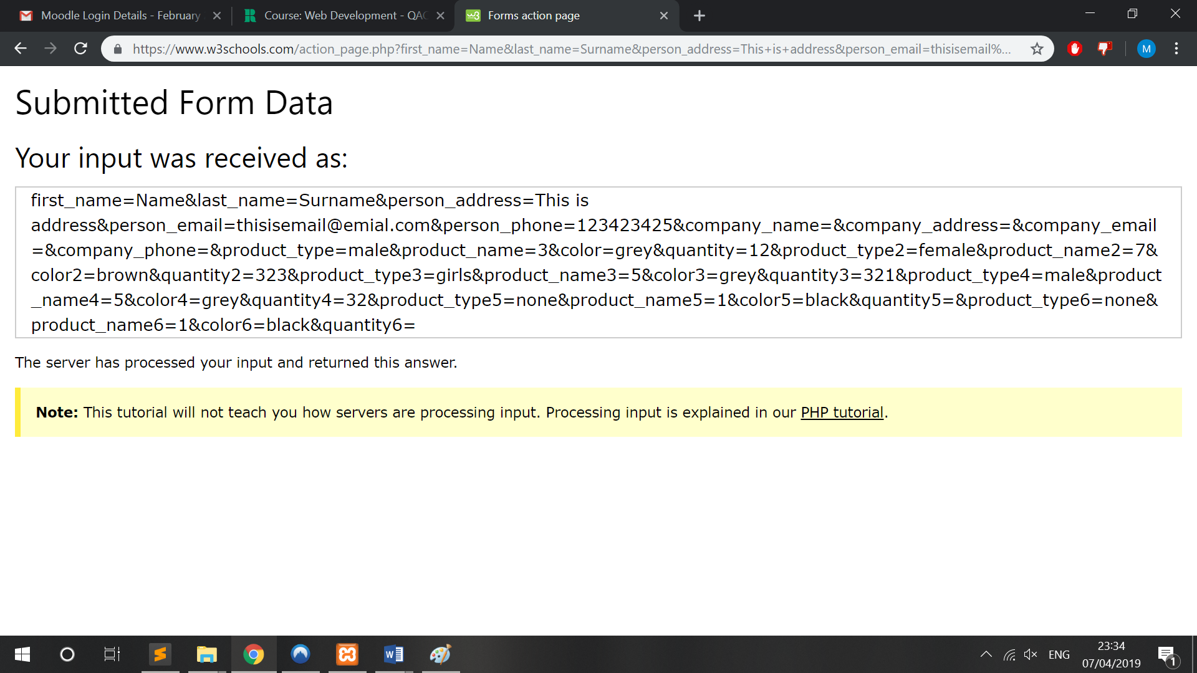

## Cross browser running test

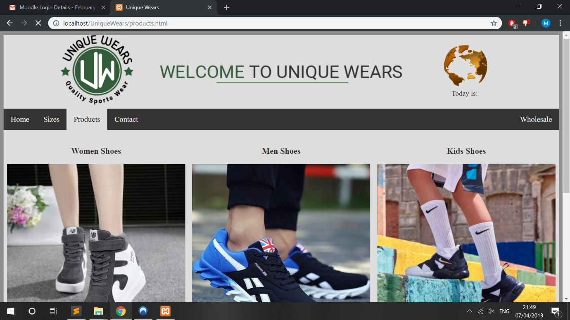

Figure 66 Google chrome

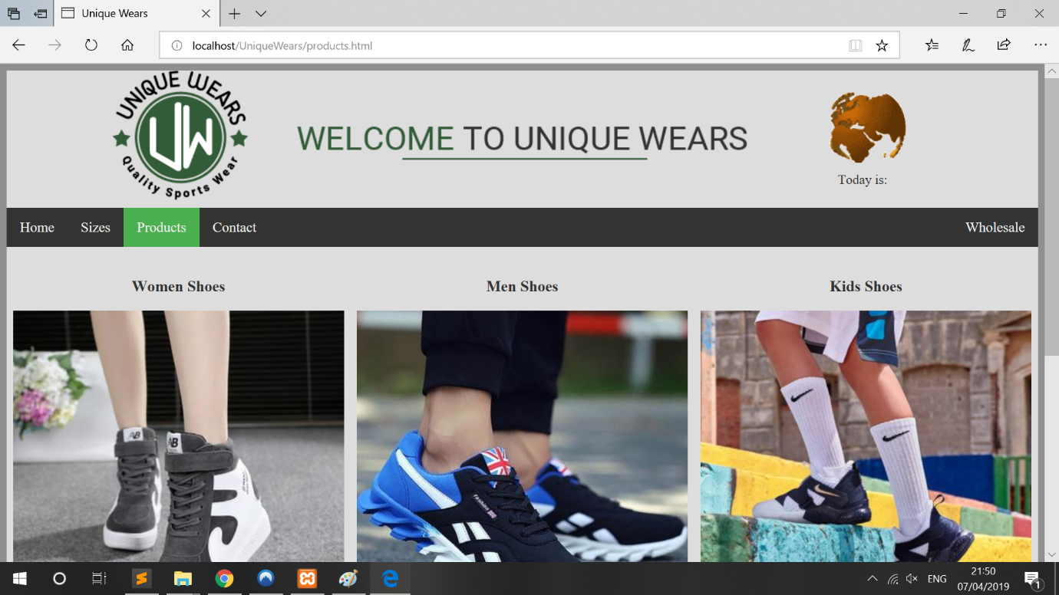

Figure 67 Microsoft edge

# References

1. Terry Ann Felke-Morris (2012). Web Development and Design Foundations with HTML5, 6th Edition
2. w3schools.com. (2007). Resposive web design. [online] <https://www.w3schools.com/CSS/css_rwd_intro.asp>
3. Colouring scheme <https://colr.org>
4. w3schools.com. (2007). CSS Navigation bar. [online] <https://www.w3schools.com/CSS/css_navbar.asp>

# Appendices

